Software Requirements Specification

for

ScrapTrace
Offline AI-Assisted E-Waste Identification, Safety Guidance and Recovery Tracking

Version 1.1 approved

10th September, 2026

ScrapTrace Project Team

Document Management Controls

Approval Signatures
Role | Responsibility | Approval / date
ScrapTrace Project Team | Confirms application goals, scope and acceptance criteria.  Confirms architecture, delivery feasibility and quality gates.  Approves model evaluation and grounded safety-content controls.  Reviews data minimisation, access control and threat controls.  Confirms operational workflow and terminology for the pilot. | Pending

Revision History
Version | Date | Author | Summary
0.1 | 10 September 2026 | ScrapTrace Project Team | Initial requirements baseline derived from the approved concept note.
1.0 | 12 September 2026 | ScrapTrace Project Team | Refined application scope, multilingual and LLM safety requirements, measurable acceptance criteria and traceability.
1.1 | 13 September 2026 | ScrapTrace Project Team | Completed the template conformance review and added formal DFD, UML use case, UML class, state-transition and ERD analysis models.

Table of Contents
Document Management Controls 1
Approval Signatures 1
Revision History 1
Table of Contents 2
1 Introduction 4
1.1 Purpose 4
1.2 Document Conventions 4
1.3 Intended Audience and Reading Guide 4
1.4 Product Scope 5
1.5 Stakeholder Register 5
1.6 References 6
2 Overall Description 6
2.1 Product Perspective 6
2.2 System Boundary and Scope Exclusions 7
2.3 Operational Concepts and Modes 8
2.4 Product Functions 8
2.5 User Classes and Characteristics 9
2.6 Operating Environment 10
2.7 Design and Implementation Constraints 10
2.8 User Documentation 11
2.9 Assumptions and Dependencies 11
3 External Interface Requirements 11
3.1 User Interfaces 11
3.2 Hardware Interfaces 12
3.3 Software Interfaces 13
3.4 Communications Interfaces 13
4 Data Requirements 14
4.1 Data Models 14
4.2 Data Volume and Growth Projections 15
4.3 Data Integrity and Validation Rules 15
4.4 Data Migration, Archiving, and Purging 15
5 System Features and Functional Requirements 16
5.1 Access, Role, Consent and Language 16
5.2 Image Capture, Category Prediction and Correction 17
5.3 Approved Safety Guidance, LLM Explanation and Multilingual Output 18
5.4 Indicative Price Estimation 20
5.5 Nearby Receiving Locations 21
5.6 Offline Capture and Synchronization 22
5.7 Recovery Record and QR Code 24
5.8 Recycler Handoff, Weight and Final Price 26
5.9 Processing Evidence, Trust Checks and Human Review 27
5.10 Journey View, Dashboard and Demonstration Reporting 28
6 Other Nonfunctional Requirements 29
6.1 Performance Requirements 29
6.2 Reliability and Availability Requirements 30
6.3 Safety Requirements 30
6.4 Security Requirements 31
6.5 Privacy Requirements 32
6.6 Maintainability and Supportability Requirements 32
6.7 Internationalization and Localization Requirements 33
6.8 Software Quality Attributes 33
6.8.1 Machine Learning and LLM Quality 33
6.9 Compliance and Regulatory Requirements 34
6.10 Business Rules 34
7 Other Requirements 35
7.1 Deployment and Environment 35
7.2 Application Acceptance Scenario 35
7.3 Release Exit Criteria 36
7.4 Risks and Mitigations 36
Appendix A — Glossary 37
Appendix B — Requirements Traceability Matrix 38
Appendix C — Analysis Models 39
C.1 Data Flow Diagrams 40
C.2 UML Use Case Diagram 41
C.3 UML Class Diagram 42
C.4 State Transition Diagram 43
C.5 Entity Relationship Diagram 44
Appendix D — Prioritization Rationale 45
Appendix E — Implementation Readiness Review 46

1 Introduction

1.1 Purpose
This Software Requirements Specification (SRS) defines what the ScrapTrace application shall do, the evidence needed to accept it and the constraints that protect users. It is the shared implementation baseline for product, design, web, backend, machine-learning, data, security, privacy and quality-assurance work.
ScrapTrace is a phone-friendly web application that helps a collector or household user identify selected e-waste, see approved safety guidance in a chosen language, view an indicative price range, find a nearby recycling facility and create a recovery record. A recycler can confirm receipt, weight and processing evidence. An authorised programme reviewer can resolve records that appear incomplete, inconsistent or duplicated.

1.2 Document Conventions
Convention | Meaning
Shall | Mandatory for the application baseline.
Should | Important if time permits; may be deferred only through a recorded product decision.
May | Optional behaviour or a permitted implementation choice.
Must / Should / Could | MoSCoW implementation priority used in requirement tables.
FR-xxx | Functional requirement identifier.
NFR-xxx | Non-functional requirement identifier.
BR-xxx | Business rule identifier.
Application | A demonstrable, testable system with seeded or sample programme data; not a live national service.

1.3 Intended Audience and Reading Guide
Audience | Use of this SRS | Recommended sections
Product owner and judges | Confirm usefulness, complete journey, novelty and application boundaries. | 1, 2, 5, 6, Appendix B
Web and backend engineers | Build interfaces, workflows, APIs, persistence and offline synchronization. | 2–6, Appendix C
ML and data engineers | Train, evaluate and integrate category prediction; govern corrections. | 4, 5.2, 6.1, 6.8.1
Safety/content reviewers | Approve cards, translations and LLM grounding behaviour. | 5.3, 6.3, 6.7, 6.8.1
Security/privacy reviewers | Assess identity, evidence, data protection and external providers. | 3–6
QA engineers | Derive functional, security, accessibility, offline and model-evaluation tests. | 5, 6, Appendix B

1.4 Product Scope
The application proves one clear journey from first image to reviewed recovery record. It demonstrates that the supplied Ghanaian scrapyard image dataset can support a useful service rather than only a stand-alone classifier.
- Identify one or more visible items as one of seven supported groups: refrigerators; laptops and desktop computers; televisions; microwaves; air conditioners; compressors; and mixed scrap.
- Let the user confirm or correct the suggested category without allowing an unreviewed correction to retrain the model automatically.
- Retrieve a reviewed safety card and use an LLM only to explain or translate that approved content; provide a safe fallback when approved content or the LLM is unavailable.
- Support English, French, Arabic, and Portuguese, with reviewed interface text and approved safety translations available offline.
- Show an indicative, dated price range and nearby participating scrapyards, collection centres or recyclers.
- Create an item or batch record with a QR code; save it offline and synchronize it safely when connectivity returns.
- Allow a recycler to confirm handoff, measured weight, final buying price and processing evidence.
- Apply transparent checks, send exceptional records to human review and show the journey on a role-appropriate dashboard.

1.5 Stakeholder Register
Stakeholder | Need | Influence | Success evidence
Collector / household user | Clear identification, safe guidelines and next step, location and fair early price information. | High | Completes a record and finds a suitable destination without technical help.
Scrapyard / recycler | Simple receipt, weight, price and evidence workflow. | High | Scans a QR code and completes a handoff with required evidence.
Programme reviewer | Reliable records and a manageable exception queue. | High | Can understand why a record was flagged and record a decision.
Programme manager / policy user | Aggregated evidence about category, area, verified weight and status. | Medium | Dashboard totals link back to underlying approved records.
Safety/content reviewer | Controlled and traceable public guidance. | High | Every guide shows approved source, version and review date.
Data/ML reviewer | Label corrections that can be checked before reuse. | Medium | Correction queue preserves original prediction and reviewer outcome.
Hackathon organiser / judge | Meaningful, working, understandable and well-documented application. | High | End-to-end demonstration and accessible documentation are available.

1.6 References
ID | Reference
R1 | ScrapTrace Concept Note, final refined version supplied by the project team, 2026.
R2 | GIZ Hackathon E-Waste Image Database concept document supplied to participants, 2026.
R3 | UNITAR and ITU, The Global E-waste Monitor 2024.
R4 | Republic of Ghana, Hazardous and Electronic Waste Control and Management Act, 2016 (Act 917).
R5 | Republic of Ghana, Data Protection Act, 2012 (Act 843). Applicability and final compliance interpretation require legal review.
R6 | GIZ, Incentive Based Collection of E-Waste in Ghana, 2020.
R7 | ISO/IEC/IEEE 29148, Systems and software engineering — Life cycle processes — Requirements engineering.
R8 | W3C, Web Content Accessibility Guidelines (WCAG) 2.1.
R9 | OWASP Application Security Verification Standard and OWASP Top 10, current project-approved versions.

2 Overall Description

2.1 Product Perspective
ScrapTrace is an offline-first progressive web application with a role-based backend. It combines an e-waste image classifier, approved safety content, a restricted LLM explanation service, a price reference, a receiving-location directory, recovery records, evidence storage and a review workflow. The application does not treat one photo or one QR code as proof of recycling; trust is built from separate collection, handoff, weight, processing and review events.
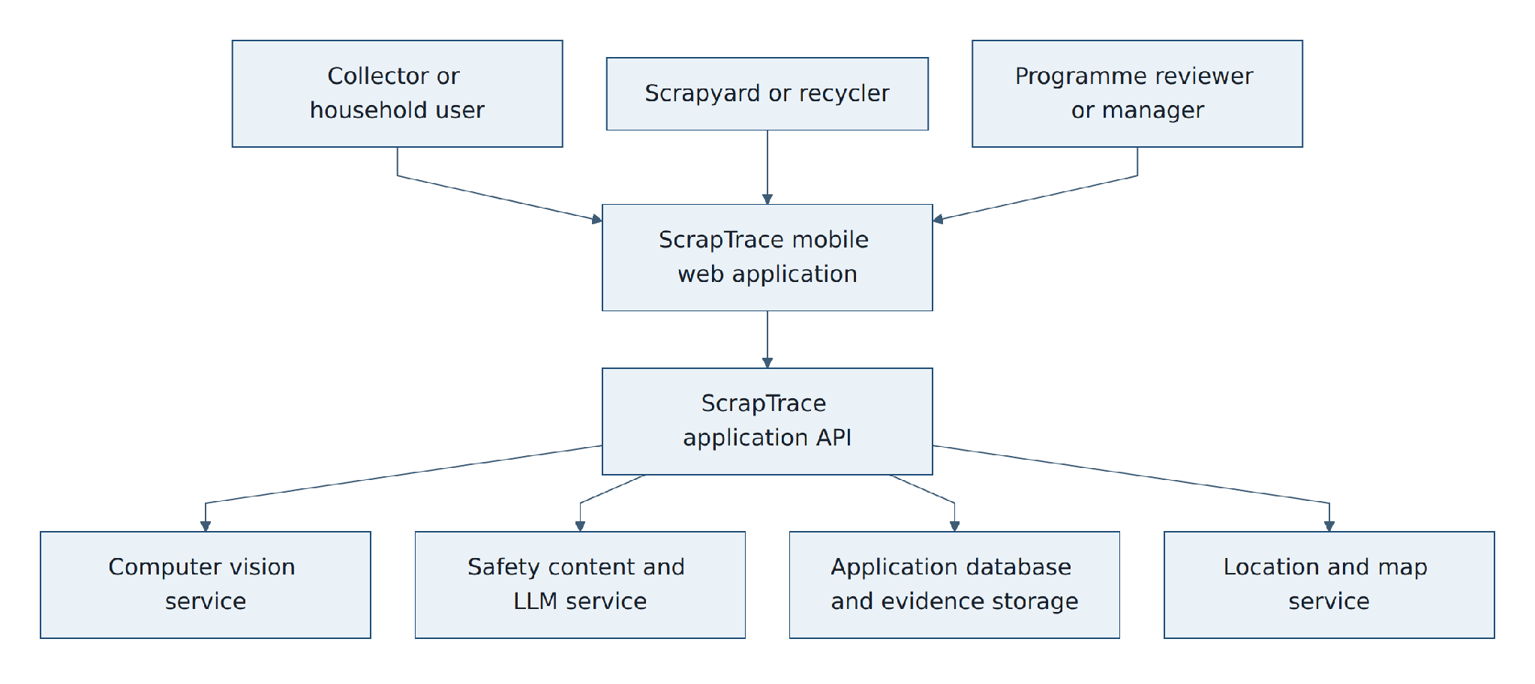
Figure 1. Application system context

2.2 System Boundary and Scope Exclusions
Inside the application | Outside the application
Phone-friendly web app, roles and demonstration authentication. | Production identity verification, national digital ID integration or full know-your-customer checks.
Seven-category image prediction with confidence and user correction. | Recognition of every device, exact material composition or automatic hazardous-condition diagnosis.
Approved cards, grounded LLM explanation, reviewed translations and fallback. | Open-ended health advice, home dismantling instructions or unreviewed AI-generated safety content.
Indicative price ranges from dated sample reference data. | Binding offers, automated market trading or guaranteed income calculations.
Seeded directory and nearest-location calculation. | Building facilities, proving every business is licensed or full national map coverage.
Recovery, handoff, processing and human-review records. | Official certificates of destruction, statutory compliance approval or EPR credit issuance.
Illustrative incentive calculation on an approved record. | Live mobile-money transfers, custody of funds or smart-contract settlement.
Reviewed corrections stored for future dataset preparation. | Automatic online learning or automatic deployment of a retrained model.

2.3 Operational Concepts and Modes
Mode | Available behaviour | Unavailable or limited behaviour
Online | Prediction service, LLM explanation, live map/directions, synchronization, reviewer dashboard and evidence upload. | Subject to external provider and network availability.
Offline | Capture draft, confirm category, show cached approved guide and translations, show cached location list, generate local record identifier and queue synchronization. | No fresh LLM response, live directions or authoritative server status.
Degraded external service | Use cached/approved text, keep record pending and show a plain-language service message. | No silent substitution of invented content or false success state.
Demonstration | Seeded users, locations, prices and records support repeatable judging; feature labels distinguish simulated incentive data. | No real payment, legal certification or production service-level promise.

2.4 Product Functions
The primary demonstration shall follow the sequence below. Each step produces information that supports the next step and remains visible in the final journey record.
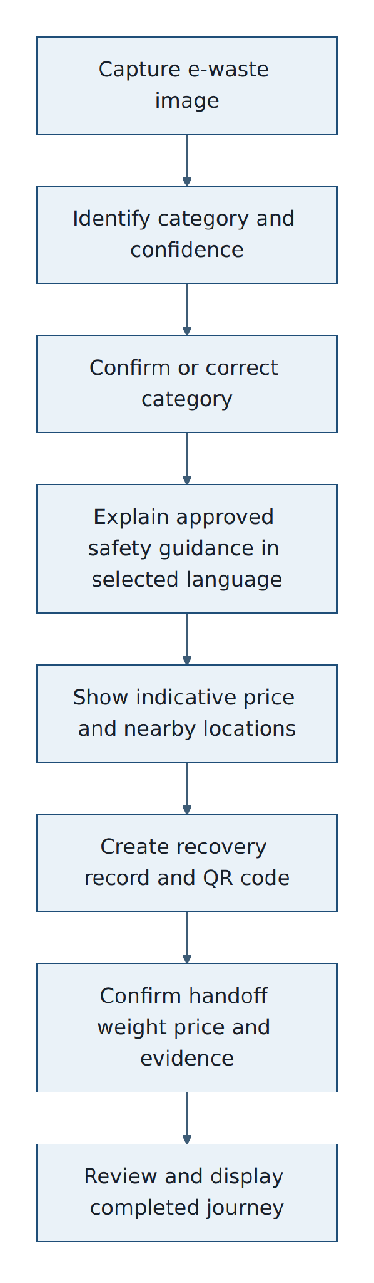
Figure 2. End-to-end application journey

2.5 User Classes and Characteristics
User class | Expected skills / constraints | Authorised actions
Collector / household user | May have basic smartphone experience, limited data, intermittent internet and varied reading ability. | Capture, confirm/correct, view guidance/price/locations, create and track own records.
Recycler operator | Uses a shared or personal phone at a receiving site; understands local weighing and intake process. | Scan record, confirm category/condition, record weight/price, upload evidence and processing result.
Programme reviewer | Trained to interpret evidence and programme rules. | Review flags, compare evidence, request information, approve or reject with reason.
Programme manager | Understands operational planning and aggregate reports. | Manage seed directory/price references and view aggregate dashboard.
Safety/content administrator | Qualified to approve e-waste guidance and translations. | Create, version, approve, publish and retire safety content.
Data/ML reviewer | Understands labels, model limits and evaluation. | Review corrected labels and export only consented, approved examples.

2.6 Operating Environment
- Client: current Android smartphone browsers with camera, geolocation and local storage support; responsive desktop browser for reviewer and dashboard use.
- Web application: installable progressive web app served over HTTPS; offline service worker and local encrypted storage where supported.
- Backend: containerised API and worker processes suitable for a managed Linux host.
- Data: PostgreSQL with spatial capability or equivalent; S3-compatible private object storage for images and evidence.
- AI: Python inference service using a versioned model artifact; provider-independent LLM adapter restricted by approved content.
- Maps: an OpenStreetMap-compatible map/geocoding/directions provider or seeded coordinates for the demonstration.

2.7 Design and Implementation Constraints
Constraint | Required response
Challenge dataset | Model classes and evaluation must align with the supplied seven groups; dataset rights and permitted reuse govern training and export.
Weak connectivity | The collector journey must not lose a validated draft when the network disappears.
Safety-critical guidance | The LLM may transform only approved facts; it may not answer outside the card or provide dismantling instructions.
Application evidence | The system must label simulated data and must not represent records as government certification.
Low-end devices | Pages, images and model requests must be compressed; the app shall avoid requiring a high-end phone.
Privacy | Precise coordinates, identity and images are protected; public/aggregate views receive only necessary data.
Schedule | Prefer modular, replaceable adapters and seeded integrations over incomplete production integrations.

2.8 User Documentation
• In-app first-use guide covering camera permission, safe capture, price disclaimer, location permission and offline status.
• Short collector guide in supported languages using plain words and images where possible.
• Recycler quick guide for scanning, weighing and acceptable evidence.
• Reviewer guide explaining every flag, decision and audit event.
• Developer README, local setup, environment-variable reference, API specification, data dictionary, model card, threat model and test strategy in the repository documentation.

2.9 Assumptions and Dependencies
ID | Assumption / dependency | Failure response
AD-01 | The supplied images can be used for application training under challenge terms. | Stop training/export and obtain written clarification.
AD-02 | A qualified reviewer can approve seven safety cards and the pilot translation. | Use English approved cards only; disable unsupported language claims.
AD-03 | Seed locations provide coordinates, type, accepted waste and contact details. | Use a clearly labelled demonstration directory.
AD-04 | The LLM provider accepts structured prompts and does not train on submitted application content under the configured plan. | Use approved static card; do not send the request.
AD-05 | Camera and local browser storage are available on the demonstration device. | Show a compatibility message and use an approved fallback test device.

3 External Interface Requirements

3.1 User Interfaces
Interface | Required elements | Key states
Collector home | Language selector; capture button; offline indicator; own recent records; privacy notice. | Online, offline, permission denied, empty records.
Capture and result | Camera guidance; image preview; predicted category; confidence wording; confirm/correct; retake. | Processing, low confidence, unsupported/unclear image, failure.
Safety guide | Five approved questions; selected language; source/version/review date; LLM explanation label; fallback. | Approved response, cached response, no approved card, LLM unavailable.
Price | Range, currency, basis, rate date, condition and weight fields; estimate disclaimer. | Complete estimate, missing weight for mixed scrap, stale reference.
Locations | Map/list switch; type; verification badge; accepted categories; hours; distance; call/directions. | Permission denied, cached list, no match, live map unavailable.
Recovery record | Summary, QR code, status timeline, sync state and destination. | Draft, pending sync, submitted, awaiting handoff, complete, under review, rejected.
Recycler intake | QR scanner/manual code; expected item; category/condition; measured weight; final price; photos. | Unknown code, already received, mismatch, evidence incomplete.
Reviewer queue | Flag reason, comparison view, evidence, audit history, approve/request/reject with reason. | Open, awaiting information, decided.
Dashboard | Filters and totals for category, collection area, receiving location, verified weight and status. | No data, filtered data, role-restricted fields.

3.2 Hardware Interfaces
Hardware | Interface | Requirement
Phone camera | Browser MediaDevices or file-capture interface | Capture a new image within the application; store orientation and safe metadata only.
GPS/location sensor | Browser Geolocation API | Request explicit permission and allow manual area/location use when permission is denied.
Printed/displayed QR code | Camera QR scanner and printable/downloadable code | Encode only a non-secret record identifier or signed lookup token.
Weighing scale | Human-readable scale display captured in evidence | No direct scale integration is required for the application.
Microphone/speaker | Optional browser text-to-speech or audio playback | Text-to-speech is separate from the LLM and shall not be required for acceptance.

3.3 Software Interfaces
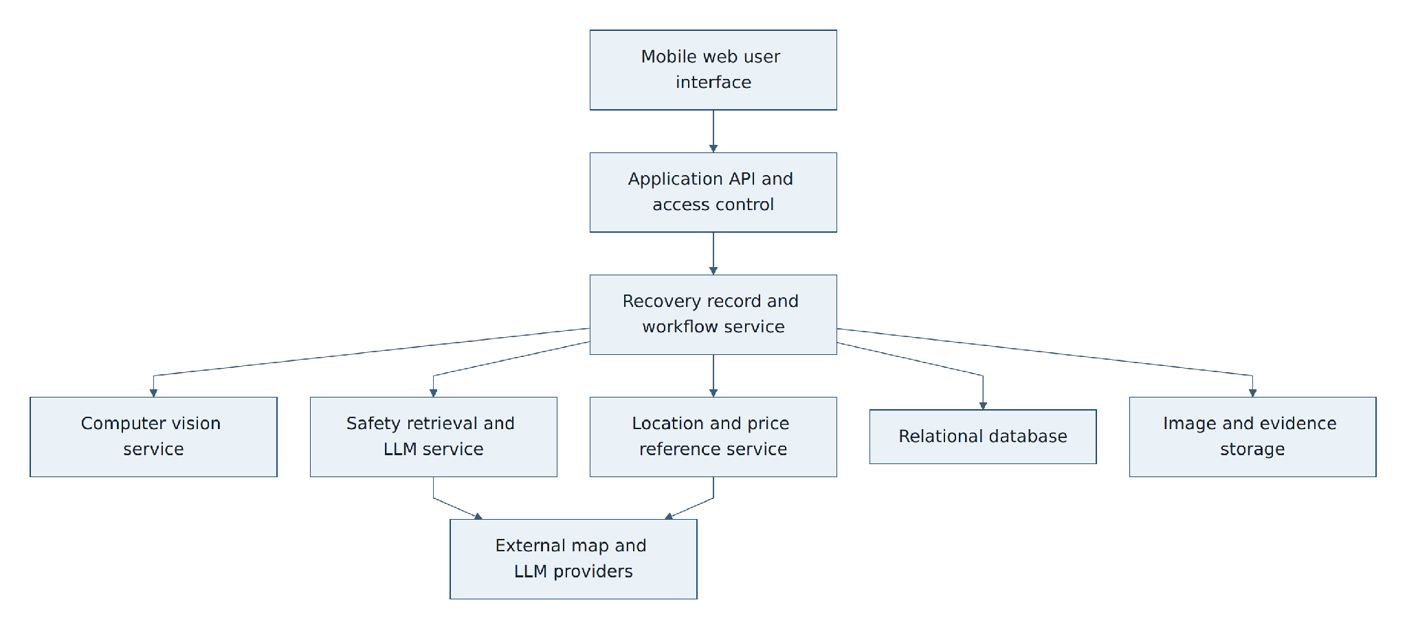
Figure 3. Logical components and external providers
Interface | Direction / data | Protocol and control
Vision inference | Image in; category scores, model version and processing result out. | Authenticated internal API; size/type validation; timeout and retry policy.
LLM provider | Approved facts, requested language and constrained task in; explanation out. | Server-side adapter; no direct client key; schema and content validation; no user PII.
Map/location provider | Coordinates or selected area in; map tiles/directions out. | HTTPS; provider terms observed; cached seed list remains available.
Object storage | Original/derived images and evidence with metadata. | Private bucket/container; server-generated keys; signed time-limited access.
Application database | Users, roles, records, events, references and review decisions. | Parameterized access through application layer; migrations under version control.

3.4 Communications Interfaces
• All external network traffic shall use HTTPS with modern TLS. Plain HTTP may exist only for local development and shall not be exposed publicly.
• Application APIs shall use versioned JSON over REST unless a documented equivalent is approved. Images use multipart upload or signed object-storage upload.
• Every client mutation shall include an idempotency key and client-generated record identifier so retries do not create duplicates.
• The client shall display offline, synchronizing, synchronized and failed states; it shall not display success before server acknowledgement.
• Push notifications, SMS, email, mobile money and government interfaces are outside the application baseline.

4 Data Requirements

4.1 Data Models
A recovery record is the aggregate root for the journey. Append-only audit events preserve who performed important actions and when. Images are stored as private objects and referenced by controlled metadata rather than embedded in public records.
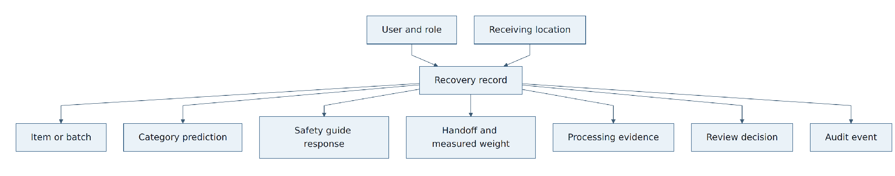
Figure 4. Core data relationships
Entity | Minimum fields | Important rules
User | user_id, role, display name or alias, preferred language, account status, consent flags | Personal details are private; role controls access.
Receiving location | location_id, name, type, coordinates, accepted categories, hours, contact, verification state/date | Only reviewed profiles may display a verified badge.
Recovery record | record_id, owner_id, item/batch type, category, count, condition, approximate area, timestamps, destination, state, sync metadata | Server controls final state transitions; public views exclude owner identity and exact coordinates.
Image/evidence | evidence_id, record_id, type, object key, digest, capture time, uploader, moderation/validation state | Private by default; validate content type, size and access.
Prediction | prediction_id, record_id, model version, per-class scores, suggested category, confirmed category, correction reason | Original output remains immutable; correction is separate.
Safety card/version | category, language, five answer fields, emergency text, sources, version, approval/review dates, status | Only approved, current content is eligible for user display or LLM grounding.
LLM response | card version, requested language, prompt template version, provider/model ID, output, validation result, timestamp | No user PII; invalid output is not shown.
Price reference/estimate | category, condition, unit, minimum/maximum, currency, source, effective date; estimate inputs/output | Estimate and final buyer price are separate.
Handoff | receiver, time, measured weight/unit, final price/currency, category/condition confirmation, evidence IDs | Cannot complete without required fields and authorised receiver.
Processing evidence | process type/result, date, operator, evidence, notes | Does not by itself create official legal certification.
Review decision | flag codes, reviewer, decision, reason, requested information, timestamps | A reviewer cannot erase original evidence or audit history.
Audit event | actor, role, action, entity, before/after references, time, request/correlation ID | Append-only through the application; protected from normal user edits.

4.2 Data Volume and Growth Projections
Data type | Application planning volume | Design response
Reference images | Approximately 5,000 supplied images plus reviewed pilot corrections. | Version datasets and manifests; do not copy unapproved user images into training data.
Recovery records | Demonstration seed: 1,000 records; acceptance test: at least 10,000 synthetic metadata records. | Indexed state, owner, location, category and date fields.
Evidence images | Up to 6 images per record; client target ≤ 2 MB each after compression. | Private object storage; thumbnails for lists; no database blobs.
Audit events | Approximately 8–20 events per record. | Append-only table partitioning is optional for application; indexes are mandatory.
Safety and location reference data | Seven categories, two application languages, up to 200 seed locations. | Cache compact, versioned bundles for offline use.

4.3 Data Integrity and Validation Rules
• Use UUID/ULID-style identifiers generated without embedding personal data. QR codes shall expose only a lookup token, not names, phone numbers or coordinates.
• Store a cryptographic digest for each uploaded image to support exact-duplicate checking. Perceptual similarity may be used as a review signal, not as automatic proof of fraud.
• Validate category against the supported taxonomy; weight must be positive and use a declared unit; prices must use a declared currency; timestamps use UTC with local display conversion.
• Keep original prediction, user confirmation, recycler confirmation and reviewer decision as separate fields/events so disagreement remains visible.
• Enforce server-side state transitions and optimistic concurrency/version checks. Offline retries use idempotency keys.
• Label coordinate precision. Store precise capture location only when necessary and consented; expose approximate area in programme views unless a role requires more.

4.4 Data Migration, Archiving, and Purging
The application replaces no legacy production system, so it has no historical-data migration. Initial data loading is limited to versioned imports of approved safety cards, sample price references, participating locations and fictional demonstration records. Each import shall be validated in a staging environment, report accepted and rejected rows, and be repeatable without creating duplicates. Database schema changes shall use reviewed, reversible migrations under version control.
Because programme and legal retention rules have not yet been formally approved, the application shall use configurable retention classes rather than hard-code a statutory period. The demonstration baseline below prevents indefinite, unexplained storage while allowing authorised review.
Data class | Application baseline | End action
Abandoned local draft | 30 days since last edit, with a user warning before removal. | Delete from device.
Submitted recovery and evidence record | Retain for the demonstration and review period; default 12 months in non-production environments. | Archive or delete through an authorised, logged job.
Rejected record | Same as submitted record unless a programme policy is approved. | Archive/delete while preserving the minimum non-personal audit proof required.
LLM request/response | 90 days by default for debugging, with no personal data. | Delete content; retain aggregate quality metrics.
Training-consented correction | Retain only after human approval and documented dataset version inclusion. | Withdraw where feasible when consent is revoked; record dataset impact.
Logs | 30–90 days depending on log type; secrets and raw images prohibited. | Automatic deletion.

5 System Features and Functional Requirements
All Must requirements form the hackathon acceptance baseline. Should requirements are valuable but may be deferred only if the end-to-end journey remains complete and the decision is recorded. Could requirements shall not displace Must work.

5.1 Access, Role, Consent and Language
Field | Definition
Description | Provide simple demonstration access, enforce roles, collect necessary permissions and let the user choose a supported language.
Application priority | Must
Primary actors | All users
Preconditions | Application is reachable; seed roles exist.
Trigger | User opens the application or a protected page.
Postconditions | A session has an authorised role, privacy choices and preferred language.
Main exceptions | Expired session; unsupported language; permission denied.

ID | Requirement | Priority | Verification | Acceptance criterion
FR-ACC-001 | The system shall provide demonstration sign-in for collector, recycler, reviewer, manager, content administrator and data reviewer roles. | Must | System test | Each seeded role reaches only its permitted landing page and API resources.
FR-ACC-002 | The server shall enforce role permissions for every protected request; hiding a control in the interface shall not be the only control. | Must | Security test | A forbidden cross-role request returns 403 and creates a security event without disclosing protected data.
FR-ACC-003 | The app shall explain camera, location, image, record and optional training-data uses before collecting them. | Must | UI test | A first-time user can read each purpose and can continue with non-essential consent declined.
FR-ACC-004 | The app shall request camera and location permissions only when the related feature is used. | Must | UI test | Opening the home page alone does not trigger a permission request.
FR-ACC-005 | The app shall offer English language, French, Arabic and Portuguese | Must | UI test | The selector changes all baseline journey labels and messages for both supported languages.
FR-ACC-006 | Reviewed interface translations shall be versioned, cached and used without an LLM. | Must | Offline test | After one successful load, the baseline interface remains translated while offline.
FR-ACC-007 | If a translation key is missing, the app shall fall back to English and log the missing key without displaying raw code tokens. | Must | Unit/UI test | A missing test key displays readable English and produces a diagnostic event.
FR-ACC-008 | The user shall be able to sign out and clear locally cached personal records from the device. | Should | UI test | After confirmation, the local account cache is cleared and protected pages require sign-in.

5.2 Image Capture, Category Prediction and Correction
Field | Definition
Description | Capture a current e-waste image, obtain a seven-class prediction and preserve user correction for later review.
Application priority | Must
Primary actors | Collector / household user; data reviewer
Preconditions | Camera available or supported capture fallback; model service configured.
Trigger | User starts a new identification.
Postconditions | Confirmed category and prediction metadata are attached to a draft record.
Main exceptions | Blurry/unsupported image; service timeout; low confidence; multiple item types.

ID | Requirement | Priority | Verification | Acceptance criterion
FR-VIS-001 | The app shall support in-application camera capture and shall clearly label any demonstration fallback that uploads a test image. | Must | UI test | On the target phone, a user can capture, preview, retake and accept an image.
FR-VIS-002 | The client shall validate accepted image type and size and compress an accepted image before upload while retaining enough detail for evaluation. | Must | Unit/system test | Invalid types are rejected; a valid oversized test image is reduced to the configured limit.
FR-VIS-003 | The inference service shall return scores for the seven supported categories, the highest category and model version. | Must | API test | A valid request returns a schema-valid result containing all seven category scores and version.
FR-VIS-004 | The interface shall show the suggested category and confidence in plain language, not present it as certain fact. | Must | UI test | Result states use wording such as high/medium/low confidence and invite confirmation.
FR-VIS-005 | The user shall confirm the suggestion or select a different supported category before continuing. | Must | UI test | A record cannot reach submitted state without a confirmed category.
FR-VIS-006 | A correction shall preserve the original prediction, selected category, user, time and optional reason. | Must | Data test | Database inspection shows both original and corrected values; the prediction is not overwritten.
FR-VIS-007 | A low-confidence or failed prediction shall display all supported categories for manual selection and a retake option. | Must | UI test | Injected low-confidence and timeout cases can still create a manually labelled draft.
FR-VIS-008 | The application shall not automatically retrain or deploy a model from user corrections. | Must | Code/config review | No correction path changes the active model artifact or training dataset automatically.
FR-VIS-009 | An authorised data reviewer shall see a queue of corrections and record approve/reject decisions for future dataset preparation. | Should | System test | Reviewer can compare image, model output, user label and later recycler label and save a decision.

5.3 Approved Safety Guidance, LLM Explanation and Multilingual Output
Field | Definition
Description | Turn the confirmed category into a safe, understandable guide. The LLM is a controlled language interface over approved facts, not the source of safety facts.
Application priority | Must
Primary actors | Collector / household user; safety/content administrator
Preconditions | Category confirmed; approved card exists or fallback is configured.
Trigger | User opens safety guidance.
Postconditions | User sees approved guidance or a safe referral, with source and review metadata.
Main exceptions | No card; expired card; unsupported language; offline; LLM timeout or invalid output.

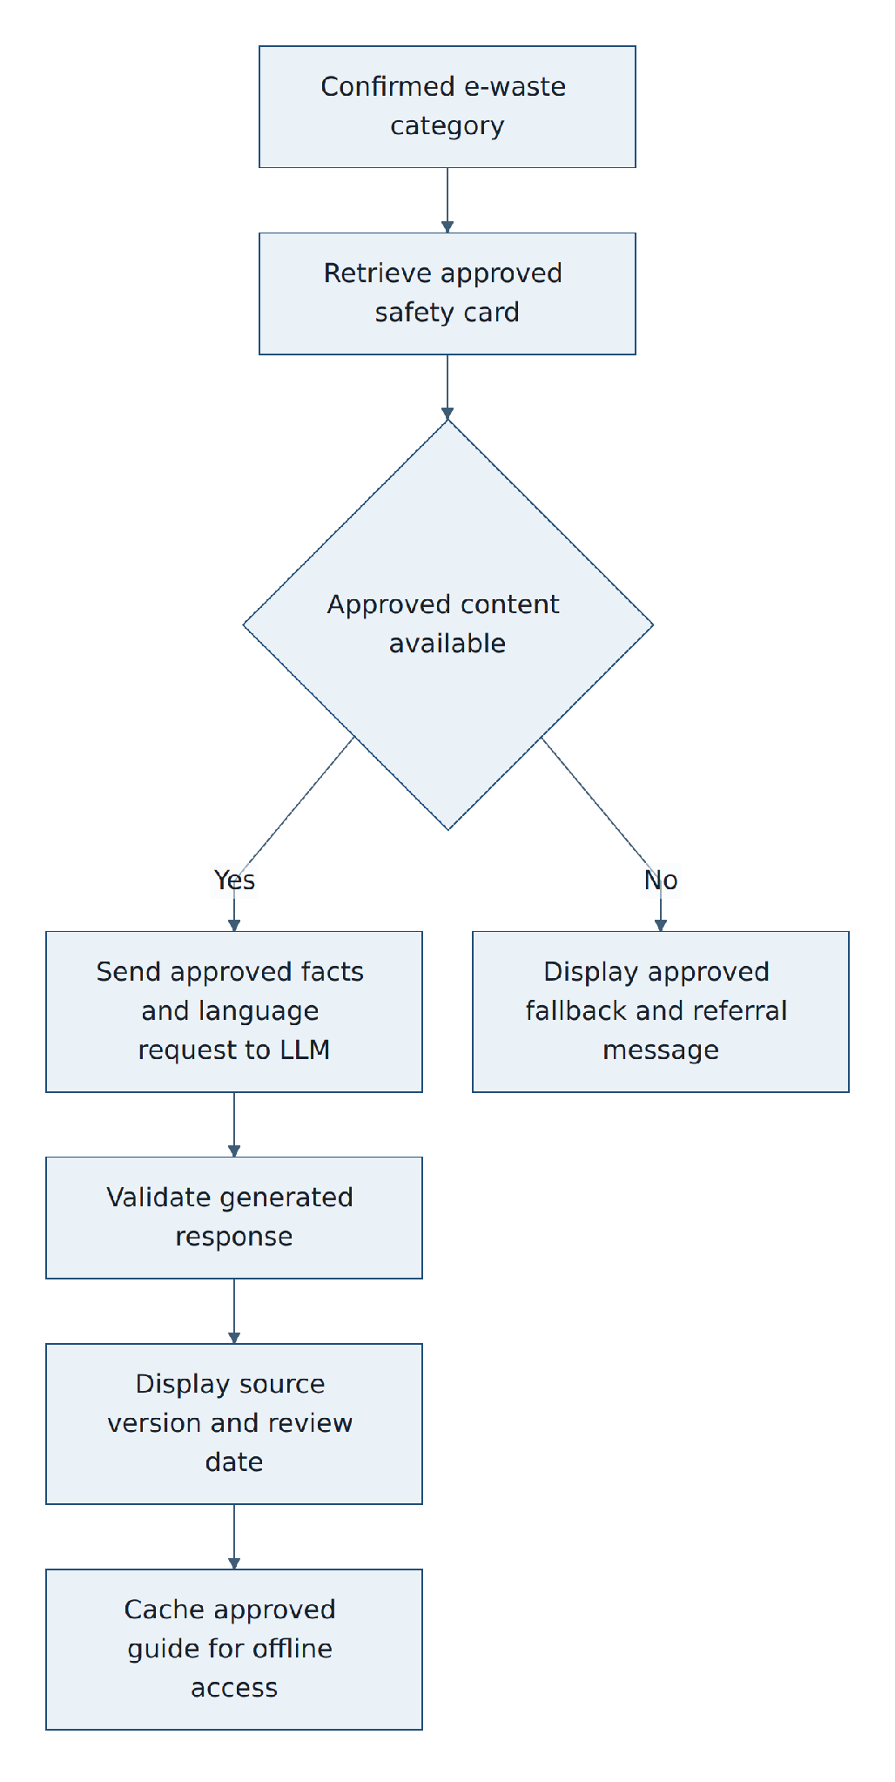
Figure 5. Grounded LLM safety-guidance flow
ID | Requirement | Priority | Verification | Acceptance criterion
FR-SAF-001 | Each supported category shall have a versioned safety card that answers: what is it; what may be dangerous; what not to do; what can be done safely now; and where to take it. | Must | Content test | Seven approved English cards contain all five fields, sources, approver, approval date and review date.
FR-SAF-002 | Only cards in Approved and current status shall be displayed as safety guidance or supplied to the LLM. | Must | API test | Draft, retired and expired test cards are excluded from user and LLM responses.
FR-SAF-003 | The LLM request shall contain only the approved card facts, requested language, tone/reading-level instruction and a rule not to add facts or dismantling steps. | Must | Integration review | Captured test requests contain no identity, coordinates, images or facts outside the selected card.
FR-SAF-004 | The LLM shall be used to explain, simplify or translate approved content and shall not answer an open-ended safety question beyond that content. | Must | Adversarial test | Prompt-injection and unrelated safety questions receive the approved fallback/referral rather than new instructions.
FR-SAF-005 | The server shall validate LLM output against a structured response schema and prohibited-action rules before display. | Must | Integration test | Malformed output and output containing a prohibited dismantling instruction are blocked.
FR-SAF-006 | If the LLM is unavailable or its output fails validation, the app shall display the approved static card in the chosen supported language when available. | Must | Failure test | With the LLM disabled, the user still sees approved guidance and a visible fallback label.
FR-SAF-007 | If no approved card exists, the app shall not ask the LLM to guess and shall direct the user to a verified receiving location or trained technician. | Must | System test | A missing-card test produces no LLM call and displays the approved referral message.
FR-SAF-008 | Every guide shall show its category, source references, card version, approval date and review date. | Must | UI test | Metadata is visible or available through an accessible ‘About this guide’ control.
FR-SAF-009 | The application shall provide reviewed safety content in English, French, Arabic, or Portuguese; LLM translation may supplement but shall not replace the reviewed offline version. | Must | Content/offline test | Both language bundles are available offline for all seven categories.
FR-SAF-010 | The app shall mark LLM-produced wording as an AI-assisted explanation and retain the source card version and model/provider metadata. | Must | UI/data test | The explanation is labelled and its stored record links to the approved card version.
FR-SAF-011 | Optional text-to-speech shall read the displayed approved or validated text and shall remain a separate service from the LLM. | Could | UI test | Disabling text-to-speech does not affect the guide; enabling it reads the visible text only.
FR-SAF-012 | Emergency conditions such as heat, smoke, fire, swelling or leakage shall use fixed reviewed wording that tells the user to move away, keep others away and contact an appropriate handler or emergency service. | Must | Content test | Emergency wording is identical to the approved version and is never freely generated.

5.4 Indicative Price Estimation
Field | Definition
Description | Provide an early, honest price range from dated reference data while reserving the final price for physical inspection and weighing.
Application priority | Must
Primary actors | Collector / household user; programme manager
Preconditions | Confirmed category; price reference exists.
Trigger | User requests an estimate.
Postconditions | Estimate inputs, range, date and disclaimer are shown and saved.
Main exceptions | Missing mixed-scrap weight; stale/missing rate; unsupported condition.

ID | Requirement | Priority | Verification | Acceptance criterion
FR-PRI-001 | The estimate shall use confirmed category, item count, user-selected condition and the active dated price reference. | Must | Unit test | Known input fixtures reproduce the approved minimum and maximum amounts.
FR-PRI-002 | For mixed scrap, the app shall require an approximate weight before calculating a range and shall state that a photo cannot measure weight reliably. | Must | UI test | The calculate action stays disabled until a positive weight and unit are entered.
FR-PRI-003 | For item categories, the user may add a known approximate weight; the estimator shall record whether weight was user-entered or absent. | Should | Unit/UI test | Both paths produce an estimate with provenance of the inputs.
FR-PRI-004 | The display shall show minimum, maximum, currency, unit/basis, condition, source and last-updated date and shall label the result as an estimate, not an offer. | Must | UI test | Every estimate view contains all listed fields and disclaimer.
FR-PRI-005 | If no current reference exists, the app shall state that an estimate is unavailable and shall not invent a price. | Must | Failure test | Missing/stale reference returns no numeric amount and shows the approved message.
FR-PRI-006 | The recycler's final price and measured weight shall be stored separately and shall never overwrite the earlier estimate. | Must | Data test | A completed test record retains both estimated range and final price.
FR-PRI-007 | Any example incentive calculation shall be visually separated from the scrap price and labelled simulated unless an approved live programme exists. | Must | UI test | Demo bonus shows its sample rule, status and separate subtotal.

5.5 Nearby Receiving Locations
Field | Definition
Description | Help the user find an appropriate participating scrapyard, collection centre or recycler without claiming that every nearby business is approved.
Application priority | Must
Primary actors | Collector / household user; programme manager
Preconditions | Seed directory loaded; location permission or manual area supplied.
Trigger | User opens Nearby locations.
Postconditions | Matching locations are ranked and a destination may be saved.
Main exceptions | Permission denied; no matching location; stale cache; provider unavailable.

ID | Requirement | Priority | Verification | Acceptance criterion
FR-LOC-001 | A location profile shall include name, type, coordinates, accepted categories, opening hours, contact details and verification state/date. | Must | Data test | All seed profiles pass schema validation; incomplete profiles cannot be published.
FR-LOC-002 | With permission, the app shall rank published locations by straight-line distance from the user's current location and filter by confirmed category. | Must | Unit/system test | Known coordinate fixtures return correctly ordered compatible locations.
FR-LOC-003 | When permission is denied, the app shall allow a user to select or enter an approximate area without blocking the journey. | Must | UI test | Denying geolocation exposes a manual-area path and suitable results.
FR-LOC-004 | Results shall clearly distinguish scrapyard, collection centre and recycler and shall show a verified badge only when a programme manager approved the profile. | Must | UI/API test | Unverified seed profiles never display the verified badge.
FR-LOC-005 | The user shall be able to view results as a list and map, call a location and open external directions when online. | Must | UI test | Actions use the selected location's stored contact and coordinates.
FR-LOC-006 | The latest reviewed compact directory shall remain available offline with its last-updated date; live directions may be unavailable. | Must | Offline test | After caching, compatible locations display offline and are marked cached.
FR-LOC-007 | If no compatible location is found, the app shall show a safe holding message and programme contact instead of suggesting unsafe disposal. | Must | Failure test | A no-match fixture displays the approved fallback and no unrelated location.
FR-LOC-008 | The manager dashboard should aggregate anonymous no-result searches by coarse area and category to indicate possible network gaps. | Should | Report test | The report contains counts without user identity or precise search coordinates.

5.6 Offline Capture and Synchronization
Field | Definition
Description | Preserve work during weak connectivity and synchronize each mutation once without hiding conflicts.
Application priority | Must
Primary actors | Collector / recycler
Preconditions | Supported browser local storage; app loaded at least once.
Trigger | Network is absent or a request fails.
Postconditions | Draft remains on device and later reaches a known server state.
Main exceptions | Storage full; session expired; duplicate; conflict; partial evidence upload.

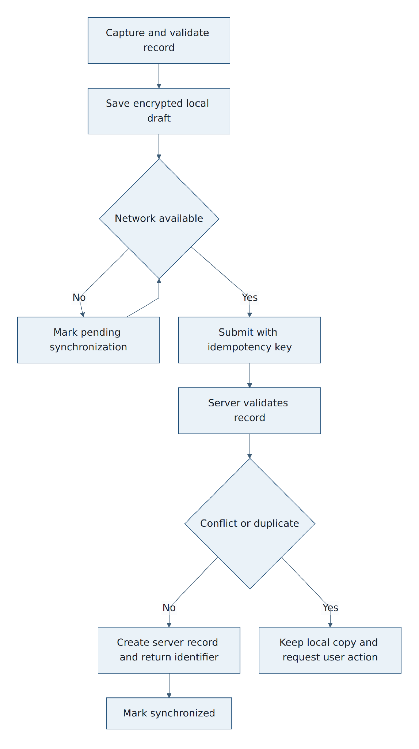
Figure 6. Offline-save and synchronization decisions
ID | Requirement | Priority | Verification | Acceptance criterion
FR-OFF-001 | The app shall save a validated draft locally before attempting network submission. | Must | Offline test | Disabling the network after capture does not lose the accepted image metadata and form values.
FR-OFF-002 | A locally saved mutation shall have a client-generated identifier, idempotency key, creation time, local version and sync state. | Must | Data test | Offline database inspection shows all required metadata.
FR-OFF-003 | The interface shall show Offline, Pending synchronization, Synchronizing, Synchronized and Action required states in plain language. | Must | UI test | Injected connection and conflict states display the matching label.
FR-OFF-004 | The client shall retry pending mutations after connectivity returns and shall use bounded exponential backoff for transient failures. | Must | Integration test | A temporary failure later succeeds without more than one server record.
FR-OFF-005 | The server shall process repeated idempotency keys as one logical mutation and return the existing result. | Must | API test | Submitting the same request three times produces one state change.
FR-OFF-006 | When server and local versions conflict, the app shall preserve the local copy, stop automatic overwrite and request authorised user action. | Must | Conflict test | A version mismatch leaves both values recoverable and displays Action required.
FR-OFF-007 | The app shall warn when local storage is nearly unavailable and shall not claim a draft is saved when storage fails. | Must | Failure test | Simulated quota failure shows an error and offers image reduction or later retry.
FR-OFF-008 | Locally cached sensitive data shall be scoped to the signed-in user and cleared on explicit sign-out/clear action. | Must | Security test | A second seeded user on the same device cannot view the first user's records.

5.7 Recovery Record and QR Code
Field | Definition
Description | Create an auditable item or batch record that links the initial collection event to later handoff and processing events.
Application priority | Must
Primary actors | Collector / household user
Preconditions | Category confirmed; required fields available or saved offline.
Trigger | User chooses Create record.
Postconditions | A unique record and QR lookup token exist with an initial audit event.
Main exceptions | Duplicate submission; required field missing; invalid state transition.

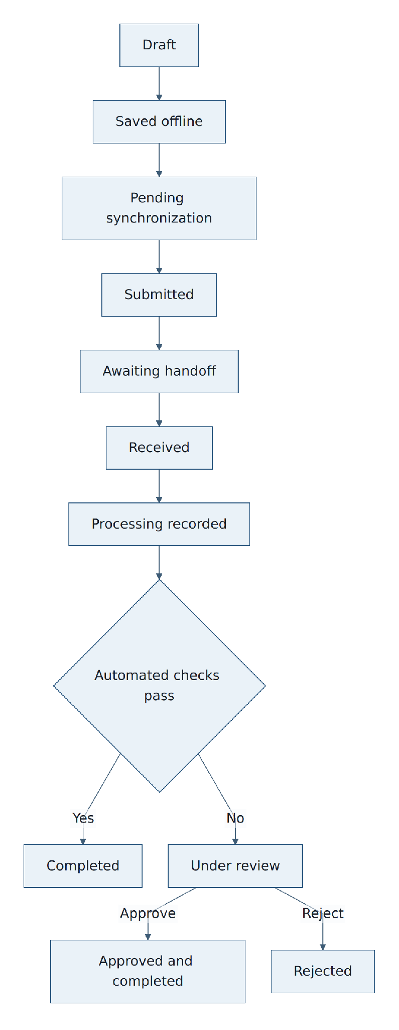
Figure 7. Recovery-record lifecycle
ID | Requirement | Priority | Verification | Acceptance criterion
FR-REC-001 | The user shall create either an individual-item record or a batch record; mixed scrap shall default to batch. | Must | UI test | Both record types are available and use the correct required fields.
FR-REC-002 | A submitted record shall contain record ID, owner, image/evidence reference, confirmed category, count or approximate weight as applicable, condition, capture time, approximate collection area, estimate and chosen destination if selected. | Must | API/data test | A valid record contains all applicable fields; incomplete input is rejected with field errors.
FR-REC-003 | The system shall generate a QR code that contains only an opaque lookup token or URL and no personal or location data. | Must | Security test | Decoding a sample QR reveals only the approved token/URL format.
FR-REC-004 | The app shall display the QR code, human-readable short code and current journey status and allow the user to reopen the record. | Must | UI test | A collector can present the record after closing and reopening the app.
FR-REC-005 | The server shall enforce the documented lifecycle and record every accepted state transition as an audit event. | Must | API test | Invalid transitions fail; valid transitions include actor, time and prior/new state.
FR-REC-006 | Changes after submission shall create a versioned change event and shall not silently replace the original value. | Must | Data test | Editing a permitted field leaves its prior value and change actor visible to reviewers.
FR-REC-007 | The app shall calculate and store an image digest and shall flag an exact digest already linked to another active record. | Must | System test | Reusing a fixture image creates a duplicate-image flag rather than automatic approval.

5.8 Recycler Handoff, Weight and Final Price
Field | Definition
Description | Let an authorised receiver independently confirm that an item or batch arrived and record measured facts.
Application priority | Must
Primary actors | Recycler operator
Preconditions | Recycler is signed in; record is Awaiting handoff.
Trigger | Recycler scans or enters the code.
Postconditions | Handoff contains receiver, measurement, final price and evidence; state advances or is flagged.
Main exceptions | Unknown/already-used code; category mismatch; impossible weight; missing evidence.

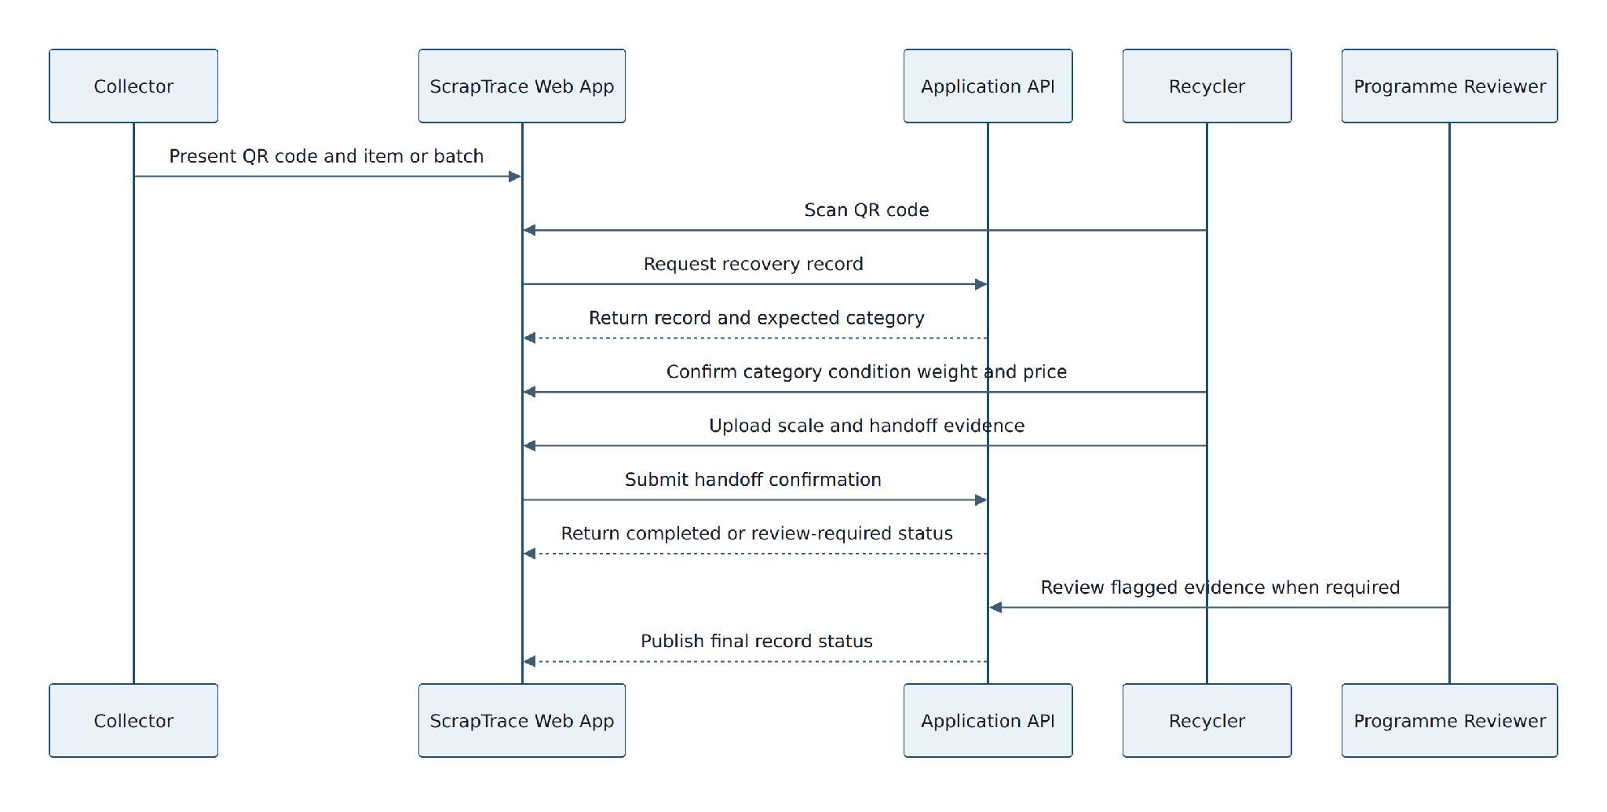
Figure 8. Handoff and review interaction sequence
ID | Requirement | Priority | Verification | Acceptance criterion
FR-HND-001 | The recycler shall scan a QR code or enter the short code to retrieve only the information needed for intake. | Must | UI/security test | A valid code opens intake; an invalid code reveals no owner data.
FR-HND-002 | The intake page shall show expected category, item/batch type and non-sensitive identifying evidence for comparison. | Must | UI test | Recycler can compare the delivered load without seeing collector contact or precise collection coordinates.
FR-HND-003 | The recycler shall independently confirm category and condition and record measured weight, unit, final buying price and currency. | Must | UI/API test | Submission requires positive weight, allowed unit, non-negative price and independent category confirmation.
FR-HND-004 | The recycler shall upload a handoff photo and scale evidence that shows the delivery and readable scale result, subject to privacy guidance. | Must | System test | The handoff cannot be marked complete without both configured evidence types or an authorised exception reason.
FR-HND-005 | The system shall record receiving location, recycler user, server time and client capture time for handoff. | Must | Data test | Completed handoff contains all provenance fields.
FR-HND-006 | A material category disagreement, unusual weight or duplicate evidence shall create a review flag rather than silently block or approve the record. | Must | Rule test | Each fixture produces the documented flag code and explanation.
FR-HND-007 | The collector's estimated range and recycler's final price shall be displayed as separate values in the journey. | Must | UI test | The completed journey labels estimate and final price distinctly.

5.9 Processing Evidence, Trust Checks and Human Review
Field | Definition
Description | Complete the recovery journey with processing evidence and transparent exception handling. Review means an authorised person compares the record and decides whether it is usable.
Application priority | Must
Primary actors | Recycler operator; programme reviewer
Preconditions | Handoff recorded.
Trigger | Recycler adds a processing result or an automated check raises a flag.
Postconditions | Record is complete, awaiting information, approved or rejected with reasons.
Main exceptions | Missing evidence; repeated image; mismatch; unusual weight; reviewer conflict.

ID | Requirement | Priority | Verification | Acceptance criterion
FR-REV-001 | The recycler shall select a processing result from a controlled list, record date and notes and attach supporting evidence. | Must | UI/API test | A processing event cannot be submitted without result, date and configured evidence.
FR-REV-002 | The system shall evaluate required evidence, exact duplicate image, category disagreement, weight threshold and invalid state rules and create named flags. | Must | Rule test | Each rule fixture produces the expected code, severity and human-readable explanation.
FR-REV-003 | A flagged record shall enter Under review and shall not be included in approved totals or simulated incentive eligibility until decided. | Must | System test | Flagged fixture is excluded from approved dashboard metrics.
FR-REV-004 | The reviewer queue shall show flag reasons, original and later categories, estimate and measured weight, evidence, locations, history and relevant model/reference versions. | Must | UI test | Reviewer can reach every listed item from one review view.
FR-REV-005 | The reviewer shall approve, request more information or reject and shall enter a reason for each decision. | Must | UI/API test | A decision without a reason is rejected; a valid decision records reviewer and time.
FR-REV-006 | Requested information shall return the record to the responsible collector or recycler without exposing reviewer-only data. | Should | System test | The responsible user sees the request and allowed upload/edit fields only.
FR-REV-007 | Only a complete unflagged record or a reviewer-approved record shall be marked Approved and completed. | Must | State test | Incomplete or undecided records cannot reach the approved terminal state.
FR-REV-008 | The audit history shall be append-only for ordinary roles and shall record creation, sync, prediction, correction, handoff, evidence, flag and decision events. | Must | Security/data test | Normal users cannot update/delete audit rows; required actions create events.
FR-REV-009 | A reviewer shall see that flags are indicators requiring judgement and are not proof of fraud. | Must | UI test | Every flag panel displays the approved explanatory statement.

5.10 Journey View, Dashboard and Demonstration Reporting
Field | Definition
Description | Explain one record from collection to outcome and provide useful aggregate information without exposing personal details.
Application priority | Must
Primary actors | Collector; recycler; reviewer; manager; judge
Preconditions | At least one record exists.
Trigger | User opens a record or dashboard.
Postconditions | Role-appropriate journey and aggregate metrics display from source records.
Main exceptions | No data; stale aggregate; restricted field; rejected record.

ID | Requirement | Priority | Verification | Acceptance criterion
FR-DSH-001 | The journey view shall show capture, confirmed category, safety-card version, estimate, destination, handoff, measured weight, final price, processing and review status in time order. | Must | UI test | A seeded complete record displays every applicable event and timestamp.
FR-DSH-002 | The collector shall see only own records; recycler users shall see records received at authorised locations; reviewer and manager access shall follow assigned scope. | Must | Security test | Cross-owner and cross-location requests are denied.
FR-DSH-003 | The manager dashboard shall filter and total records by date, category, coarse collection area, receiving location and status. | Must | Report test | Filters return totals that reconcile with seeded source records.
FR-DSH-004 | Verified weight totals shall include only Approved and completed records and shall identify the weight unit. | Must | Report test | Flagged, rejected and draft fixtures are excluded.
FR-DSH-005 | The dashboard shall display data freshness time and active filters and shall not present incomplete records as verified recycling. | Must | UI test | Freshness, filter chips and status definitions are visible.
FR-DSH-006 | The demonstration shall include a clearly labelled simulated safe-delivery bonus calculation using an approved sample rate and verified weight. | Should | Demo test | The calculation shows inputs, formula, result and ‘simulation—no payment sent’.
FR-DSH-007 | The application shall export a CSV of authorised aggregate or record data without private image URLs, phone numbers or precise coordinates. | Could | Security/report test | Export fields match the approved export schema and role.

6 Other Nonfunctional Requirements

6.1 Performance Requirements
Performance shall be measured on the agreed demonstration phone, a current desktop browser, a seeded 10,000-record metadata dataset and a documented test network. External-provider outage time is measured separately.
ID | Requirement | Verification | Acceptance criterion
NFR-PERF-001 | A local draft save shall complete within 2 seconds for 95% of attempts on the target phone. | Instrumented test | At least 95 of 100 saves meet the threshold; none loses accepted data.
NFR-PERF-002 | A category prediction shall return within 5 seconds for 95% of valid compressed images under the documented demo network and hosting profile. | Load test | At least 95 of 100 sequential requests meet the threshold.
NFR-PERF-003 | Non-AI API reads and writes shall respond within 2 seconds at the 95th percentile under 20 concurrent demonstration users. | Load test | p95 ≤ 2 seconds and error rate < 1%.
NFR-PERF-004 | The dashboard shall load seeded summary data within 5 seconds and paginate record lists. | System test | First useful dashboard render ≤ 5 seconds; no unbounded list query.
NFR-PERF-005 | Client evidence images shall target 2 MB or less after compression; server maximum shall be configurable. | Upload test | A supported oversized image is compressed or rejected with a clear limit.

6.2 Reliability and Availability Requirements
ID | Requirement | Verification | Acceptance criterion
NFR-REL-001 | A validated local draft shall survive browser close/reopen and temporary network loss. | Recovery test | Ten interruption scenarios recover all committed local fields.
NFR-REL-002 | Synchronization shall be idempotent and shall never create more than one server record for the same client mutation. | Integration test | Repeated and reordered retries preserve one logical result.
NFR-REL-003 | External AI, map or LLM failure shall degrade only the dependent function and shall not corrupt the recovery record. | Fault-injection test | Each provider outage produces a bounded error/fallback and leaves records usable.
NFR-REL-004 | The demonstration deployment shall publish a health endpoint and collect service-error metrics without personal data. | Operations test | Health checks report component status; logs contain correlation IDs and no raw secrets.
NFR-REL-005 | No production availability SLA is claimed. The hackathon environment target is 99% during the agreed judging window, excluding organiser network failure. | Monitoring review | Uptime report covers the judging window and documents exclusions.

6.3 Safety Requirements
ID | Requirement | Verification | Acceptance criterion
NFR-SAFE-001 | Safety content shall be approved by a qualified reviewer before publication and shall carry source, version, approval and review metadata. | Content audit | All seven category cards and both languages pass the release checklist.
NFR-SAFE-002 | The system shall not give home dismantling, burning, chemical extraction, refrigerant release or battery-puncture instructions. | Adversarial test | The prohibited-prompt suite produces refusal/fallback in every case.
NFR-SAFE-003 | Emergency wording shall be fixed, reviewed and available offline. | Offline/content test | All configured emergency triggers show the approved text without an external call.
NFR-SAFE-004 | The UI shall distinguish identification, advice, estimate and verified outcome so uncertainty is not hidden. | UX review | Each result uses the approved label and uncertainty/disclaimer text.
NFR-SAFE-005 | A failed AI or content control shall fail safe: no guidance is preferable to invented hazardous guidance. | Fault test | Blocked/failed content produces referral and creates a diagnostic event.

6.4 Security Requirements
ID | Requirement | Verification | Acceptance criterion
NFR-SEC-001 | All public traffic shall use HTTPS; secrets shall be server-side environment/secret-manager values and never committed or sent to the browser. | Configuration scan | TLS passes project baseline; repository secret scan has no unresolved high finding.
NFR-SEC-002 | Authentication tokens shall use secure, same-site, HTTP-only cookies or an equivalently reviewed mechanism; sessions shall expire and be revocable. | Security test | Browser tests confirm cookie flags and revoked/expired sessions fail.
NFR-SEC-003 | Every protected resource shall enforce object-level and role-level authorisation. | Access-control test | The role/object matrix has no unauthorised successful request.
NFR-SEC-004 | Uploads shall be size/type validated, assigned server-generated object keys, malware-scanned where the platform supports it and served from private storage with short-lived access. | Upload test | Polyglot/invalid fixtures are rejected; object enumeration and permanent public access fail.
NFR-SEC-005 | Database access shall use parameterized queries or a safe ORM; state-changing requests shall resist CSRF where cookies are used. | SAST/DAST | No high-severity injection or CSRF finding remains open for release.
NFR-SEC-006 | Security-relevant actions shall be logged with actor, action, time, target and correlation ID, excluding secrets and raw safety prompts containing user data. | Log review | Test actions are traceable and logs contain no prohibited fields.
NFR-SEC-007 | Dependencies and containers shall be scanned; critical/high findings require remediation or a documented time-bound acceptance before release. | CI scan | Release report lists no unreviewed critical/high finding.
NFR-SEC-008 | LLM input shall treat all user text and retrieved content as untrusted; prompt instructions and output validation shall resist injection. | Adversarial test | The injection suite cannot reveal secrets, change role, add facts or bypass prohibited-action filters.

6.5 Privacy Requirements
ID | Requirement | Verification | Acceptance criterion
NFR-PRV-001 | Collect only information required for the application journey and document each field's purpose, visibility and retention class. | Data inventory | Every production table/API field maps to the approved data dictionary.
NFR-PRV-002 | Precise coordinates, identity and private evidence shall not appear on public or aggregate dashboards. | Privacy test | Public/manager responses expose only the approved coarse area and aggregate fields.
NFR-PRV-003 | The LLM provider shall receive no name, phone, account ID, precise coordinate or image. | Integration inspection | Captured outbound requests contain none of the prohibited fields.
NFR-PRV-004 | Use of a user's image or correction for future training shall require separate opt-in consent and human approval. | Consent test | Declined or absent consent prevents dataset export.
NFR-PRV-005 | Users shall be told what is collected, why, who can see it, whether it is optional and how to request correction/deletion for the pilot. | Content review | Plain-language notice covers all items and is accessible before submission.
NFR-PRV-006 | The project shall perform a privacy impact review before any field pilot or production deployment. | Governance gate | A signed review and action log exists before pilot data collection.

6.6 Maintainability and Supportability Requirements
ID | Requirement | Verification | Acceptance criterion
NFR-MNT-001 | The monorepo shall separate web, API, ML, shared contracts, infrastructure and documentation with declared ownership. | Repository review | Structure matches the approved architecture and has no circular package dependency.
NFR-MNT-002 | The API shall publish an OpenAPI specification and shared schemas shall be versioned. | Contract test | Generated/checked schema matches running endpoints and client types.
NFR-MNT-003 | Database changes shall use reversible, reviewed migrations; seed data shall be deterministic and contain no real personal data. | CI test | Fresh setup and upgrade/downgrade test pass in CI.
NFR-MNT-004 | Critical paths shall have automated unit, integration and end-to-end tests covering online, offline, role and failure states. | Coverage review | Release checklist shows passing tests for every Must acceptance flow.
NFR-MNT-005 | Logs, metrics and traces shall use correlation IDs and shall avoid secrets, raw personal data and full image URLs. | Observability review | Sample telemetry links a request across services without prohibited data.
NFR-MNT-006 | Feature flags/configuration shall separate simulated incentive, optional TTS and external providers from core recovery flow. | Configuration test | Disabling an optional feature leaves the Must journey functional.

6.7 Internationalization and Localization Requirements
ID | Requirement | Verification | Acceptance criterion
NFR-I18N-001 | All text shall use UTF-8 and translatable strings shall be externalized; no baseline interface text shall be hard-coded in components. | Code review | Localization-key scan covers the end-to-end journey.
NFR-I18N-002 | The application shall support English, French, Arabic, and Portuguese with human-reviewed UI and safety translations. | Localization test | Both languages complete the journey with no untranslated critical string.
NFR-I18N-003 | Dates, times, numbers, currency and units shall be locale-aware while canonical server values remain unambiguous. | Unit/UI test | Fixtures render correctly and round-trip without value change.
NFR-I18N-004 | The selected language shall persist for the user and remain effective offline; English is the explicit fallback. | Offline test | Language remains selected after restart and network loss.
NFR-A11Y-001 | Core pages shall target WCAG 2.1 AA: keyboard operation, visible focus, labelled controls, alternatives for images and sufficient contrast. | Automated/manual audit | No critical automated finding; keyboard and screen-reader smoke test passes.
NFR-A11Y-002 | Instructions shall use plain language, short actions and icons with text; colour alone shall not communicate status. | UX/content review | All status states have text/icon labels and pass the readability checklist.
NFR-A11Y-003 | Touch targets shall be at least 44 by 44 CSS pixels for primary mobile actions. | UI measurement | Target-device inspection confirms all primary actions.

6.8 Software Quality Attributes
The application's quality attributes are measurable rather than descriptive labels. Reliability is defined in Section 6.2, safety in Section 6.3, security and privacy in Sections 6.4 and 6.5, accessibility in Section 6.7, and maintainability and testability in Section 6.6. The requirements below define the additional quality controls for the computer-vision model and the grounded LLM feature.

6.8.1 Machine Learning and LLM Quality
ID | Requirement | Verification | Acceptance criterion
NFR-AI-001 | The vision dataset shall be split by an approved method that prevents the same or near-duplicate image from appearing across train and test sets. | Data audit | Dataset manifest and duplicate report confirm the separation.
NFR-AI-002 | The model card shall report dataset version, class counts, split method, per-class precision/recall/F1, confusion matrix, threshold and known limitations. | Document review | All fields are present for the release candidate model.
NFR-AI-003 | A release model shall meet a product-approved macro-F1 threshold established after baseline evaluation; until approved, the minimum candidate target is macro-F1 ≥ 0.70 on the held-out challenge test split with no class recall below 0.50. | Model evaluation | Signed evaluation report meets threshold or release is blocked/marked limited.
NFR-AI-004 | Low confidence shall trigger manual confirmation; the threshold shall be configurable and documented from validation results. | Model/UI test | Below-threshold fixtures never auto-advance without user selection.
NFR-AI-005 | Corrections shall enter a human-reviewed queue and shall not alter the live model until a versioned retraining and regression-evaluation cycle is approved. | Pipeline review | No path directly trains/deploys from user input; model registry preserves prior version.
NFR-LLM-001 | A grounded-response evaluation set shall cover all seven categories, both languages, missing-card, provider-failure and injection cases. | Evaluation run | 100% of prohibited-safety cases refuse/fallback; all displayed factual points are traceable to the card.
NFR-LLM-002 | LLM model/provider, prompt template, card version, validation result and latency shall be observable without logging user identity. | Telemetry test | A test response can be reproduced/audited from non-personal metadata.
NFR-LLM-003 | Changing an external model or prompt template shall require regression evaluation before demonstration deployment. | Release gate | CI/release checklist links to a passing grounded-response report.

6.9 Compliance and Regulatory Requirements
ID | Requirement | Verification | Acceptance criterion
NFR-CMP-001 | The application shall describe its alignment with Ghana Act 917 but shall not claim regulatory approval, issue an EPR credit or call a record a statutory certificate. | Content/legal review | User-facing and exported text contains the approved non-certification statement.
NFR-CMP-002 | Personal-data handling shall be designed toward Ghana Data Protection Act, 2012 (Act 843), subject to legal review before field use. | Privacy/legal review | Data inventory, lawful-purpose analysis, rights process and processor list are reviewed.
NFR-CMP-003 | External dataset, map, model, font and code licences/terms shall be recorded and followed. | Licence scan | Dependency and data register has no unresolved incompatible use.
NFR-CMP-004 | Accessibility shall target WCAG 2.1 AA for the core journey. | Accessibility audit | Release report records automated and manual results and accepted exceptions.

6.10 Business Rules
ID | Rule
BR-001 | The supported application taxonomy contains exactly seven top-level categories from the supplied challenge dataset.
BR-002 | The user's confirmed category drives guidance and estimation; the original model result remains part of the record.
BR-003 | A safety card must be approved and current before it is displayed or used to ground the LLM.
BR-004 | The LLM may explain or translate approved facts only; it must not invent facts or dismantling instructions.
BR-005 | A mixed-scrap estimate requires approximate weight; every price result is indicative until recycler confirmation.
BR-006 | Only programme-reviewed profiles display a verified location badge.
BR-007 | One idempotency key represents one logical mutation; one record ID identifies one item or declared batch.
BR-008 | A record cannot be Approved and completed without required handoff and processing evidence and no unresolved review flag.
BR-009 | A flag indicates a need for review; it does not by itself prove fraud or wrongdoing.
BR-010 | Only Approved and completed records contribute to verified-weight totals or simulated incentive eligibility.
BR-011 | The application does not send money, issue official EPR credits or certify legal compliance.
BR-012 | Training reuse requires separate user consent, human label approval and a versioned dataset release.

7 Other Requirements

7.1 Deployment and Environment
- Provide local development, continuous-integration and demonstration environments. Production is not part of this SRS.
- Use infrastructure configuration and environment-specific secrets. Demonstration seed data shall be repeatable and contain fictional identities.
- Provide a one-command documented setup for supported development systems or a container-based equivalent.
- Provide rollback instructions for web/API deployment and model artifact selection.

7.2 Application Acceptance Scenario
Step | Demonstration action | Required observable result
1 | Collector selects the language and captures a television while connectivity is disabled. | Translated UI, local save and offline state are visible.
2 | The model suggests a category; collector corrects or confirms it. | Confidence and original/confirmed values are retained.
3 | Collector opens guidance, price and nearby places. | Approved offline guide with provenance, honest estimate and cached compatible locations display.
4 | Connectivity returns and the record synchronizes. | One server record and one QR code exist; no duplicate is created.
5 | Recycler scans, confirms, weighs and uploads handoff/processing evidence. | Measured weight/final price remain distinct from the estimate; audit events are added.
6 | A deliberate mismatch creates a review flag. | Record is excluded from approved totals and appears with an explained flag.
7 | Reviewer approves with a reason. | Journey becomes Approved and completed; dashboard verified weight updates.
8 | Manager opens simulated bonus view. | Calculation is traceable and clearly states that no payment was sent.

7.3 Release Exit Criteria
- All Must functional requirements pass or have a documented, owner-approved waiver that does not break the end-to-end acceptance scenario.
- All critical-path tests pass in the target demonstration environment, including offline save/sync, role access, grounded LLM fallback and review workflow.
- No unresolved critical/high security vulnerability; privacy and safety release checklists are signed.
- Model card and LLM grounded-response evaluation meet the approved release thresholds or limitations are visibly disclosed in the application.
- Seven safety cards and two language bundles are approved, dated and available offline.
- README, setup, API, data dictionary, test evidence and judge-facing demo script are reachable and legible.

7.4 Risks and Mitigations
Risk | Effect | Application mitigation | Owner
Vision accuracy differs by class or field condition. | Wrong category may select wrong guidance/estimate. | Show uncertainty; require confirmation; report per-class metrics; manual path. | ML lead
LLM adds unsafe or unsupported content. | Potential physical harm and loss of trust. | Ground only on approved card; structured validation; prohibited rules; static fallback. | AI safety lead
Location or price seed data becomes stale. | Wasted travel or misleading value. | Show source/date; verification status; no-result/stale message. | Product/programme lead
Offline retry creates duplicates. | Inflated records and review burden. | Client IDs, idempotency keys, server uniqueness and conflict UI. | Backend lead
Evidence images expose people or locations. | Privacy/security harm. | Capture guidance, private storage, least-privilege URLs, coarse public views. | Privacy/security lead
Scope expands into payments/certification. | Incomplete application and misleading claims. | Feature flags, explicit exclusions and simulated labels. | Engineering/product lead
Pilot language translation is inaccurate. | Unsafe or confusing advice. | Human review, versioning, English fallback and community validation before field use. | Content lead

Appendix A: Glossary
Term | Meaning in this SRS
Approved and completed | Terminal record state reached after required evidence passes checks or an authorised reviewer approves it.
Batch | A declared group of small parts or mixed scrap tracked under one recovery record.
Collector | A person who finds, collects or brings e-waste into the recovery journey; may include a household user.
Confidence | The model's score for how strongly the image matches a category; it is not certainty.
EPR | Extended Producer Responsibility: a policy approach in which producers have responsibility for products after use.
Evidence | A protected image, measurement, form entry or event supporting a step in the recovery journey.
Flag | A named indicator that a record needs human attention; not proof of fraud.
Grounding | Restricting an LLM response to supplied approved facts rather than allowing it to invent content.
Handoff | The event in which a receiving location accepts and weighs an item or batch.
Idempotency key | A unique value that lets repeated network requests produce one logical result.
Indicative price | A non-binding range based on reference information before physical inspection and weighing.
LLM | Large Language Model used here only to explain, simplify or translate approved safety content.
Mixed scrap | A batch of assorted electronic parts or materials for which an approximate weight is required.
Offline-first | Design in which useful work is saved locally and synchronized when connectivity returns.
Programme | An authorised collection, take-back or incentive initiative using records under defined rules.
PWA | Progressive Web Application: a web app that can support installation-like behaviour and offline caching.
Recovery record | The central record linking collection, guidance, estimate, destination, handoff, processing and review.
Recycler | A participating receiving or processing organisation; verification status must be shown separately.
Safety card | A versioned and human-approved set of facts for one e-waste category.
Simulated incentive | A demonstration-only calculation; no funds are moved.
Verified location | A profile reviewed by an authorised programme manager; the badge is not a universal legal certification.

Appendix B: Requirements Traceability Matrix
The matrix maps stakeholder needs to functional groups, verification evidence and application acceptance. Individual requirement tables provide the lower-level acceptance criterion for every ID.
Need | Stakeholder outcome | Requirements | Verification evidence | Acceptance link
NEED-01 | Collector can identify an item and correct uncertainty. | FR-VIS-001–009; NFR-AI-001–005 | Model evaluation; capture/correction system tests | Acceptance steps 1–2
NEED-02 | User receives safe, understandable, multilingual guidance. | FR-ACC-005–007; FR-SAF-001–012; NFR-SAFE; NFR-I18N; NFR-LLM | Content audit; offline; adversarial and localization tests | Acceptance steps 1–3
NEED-03 | User sees a realistic estimate without false precision. | FR-PRI-001–007; BR-005 | Estimator unit/UI tests | Acceptance step 3
NEED-04 | User finds a suitable participating location. | FR-LOC-001–008; NFR-PRV-002 | Distance, filter, offline and privacy tests | Acceptance step 3
NEED-05 | Work continues through weak connectivity. | FR-OFF-001–008; NFR-REL-001–003 | Interruption, retry, conflict and recovery tests | Acceptance steps 1 and 4
NEED-06 | Collection is linked to a traceable item or batch. | FR-REC-001–007; NFR-SEC-003–006 | Lifecycle, QR, duplicate and access tests | Acceptance step 4
NEED-07 | Recycler records independent handoff facts and processing evidence. | FR-HND-001–007; FR-REV-001 | Recycler end-to-end and data-integrity tests | Acceptance step 5
NEED-08 | Programme can understand and resolve inconsistent records. | FR-REV-002–009; BR-008–010 | Rule fixtures, review-state and audit tests | Acceptance steps 6–7
NEED-09 | Users and managers understand the full journey and useful totals. | FR-DSH-001–007; NFR-PERF-004 | Reconciliation, role and performance tests | Acceptance steps 7–8
NEED-10 | Personal data and evidence are protected. | FR-ACC; NFR-SEC; NFR-PRV | Threat model, DAST/SAST, access matrix and privacy test | Release exit criteria
NEED-11 | Application is honest about legal and commercial limits. | Scope exclusions; BR-011; NFR-CMP | Content/legal review | All acceptance steps
NEED-12 | Corrections can improve future data without unsafe live learning. | FR-VIS-006, 008–009; NFR-AI-005; BR-012 | Pipeline, consent and dataset-export review | Post-demo review

Appendix C: Analysis Models
This appendix contains the formal analysis models requested by the SRS template. The diagrams use straight connectors and separate system behaviour, software structure, record states and stored data so developers and testers can use each model for a specific purpose. The earlier figures remain beside the requirements they explain; the models below provide the formal DFD, UML, state-transition and ERD views.
Figure | Model | Section | Implementation use
1 | System context | 2.1 | System boundary, actors and external dependencies.
2 | Application journey | 2.4 | Primary happy-path demonstration and feature ordering.
3 | Logical components | 3.3 | Service boundaries and external adapters.
4 | Core data relationships | 4.1 | Schema decomposition and ownership.
5 | Grounded LLM guidance | 5.3 | Safety-card retrieval, validation and fallback.
6 | Offline synchronization | 5.6 | Local persistence, idempotency and conflict handling.
7 | Record lifecycle | 5.7 | Server state machine and terminal outcomes.
8 | Handoff sequence | 5.8 | Actor/service responsibilities during intake and review.
9 | Context DFD | Appendix C.1 | External actors, the system boundary and exchanged information.
10 | Level 1 DFD | Appendix C.1 | Internal processes, data stores and end-to-end data movement.
11 | UML use case model | Appendix C.2 | Actor goals and the system capabilities available to each role.
12 | UML class model | Appendix C.3 | Domain classes, responsibilities and software relationships.
13 | State-transition model | Appendix C.4 | Permitted recovery-record states and transition triggers.
14 | Entity-relationship model | Appendix C.5 | Persistent entities, keys and cardinalities.

C.1 Data Flow Diagrams
The context DFD treats ScrapTrace as one process and shows only information that crosses its boundary. The Level 1 DFD then decomposes the application into capture, enrichment and synchronization, handoff and processing, and programme review. D1 to D4 are logical data stores, not separate technology products.
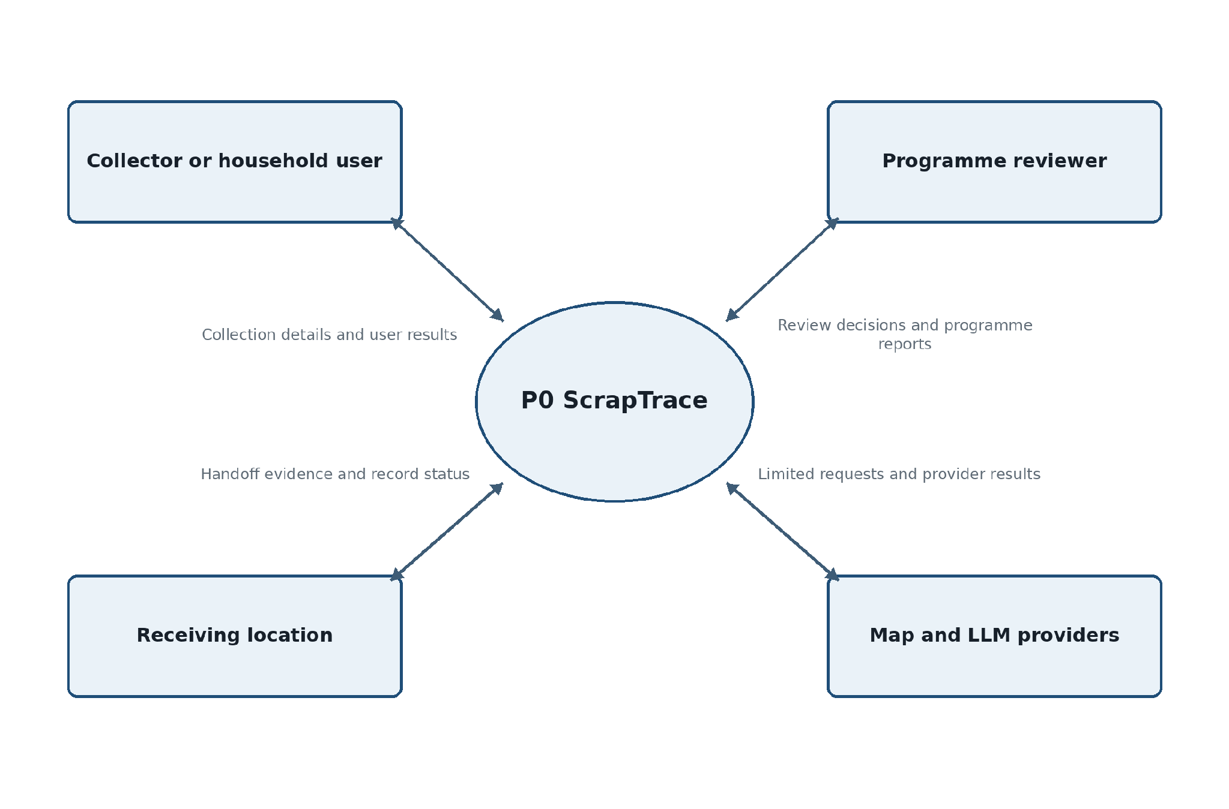
Figure 9. Context data flow diagram
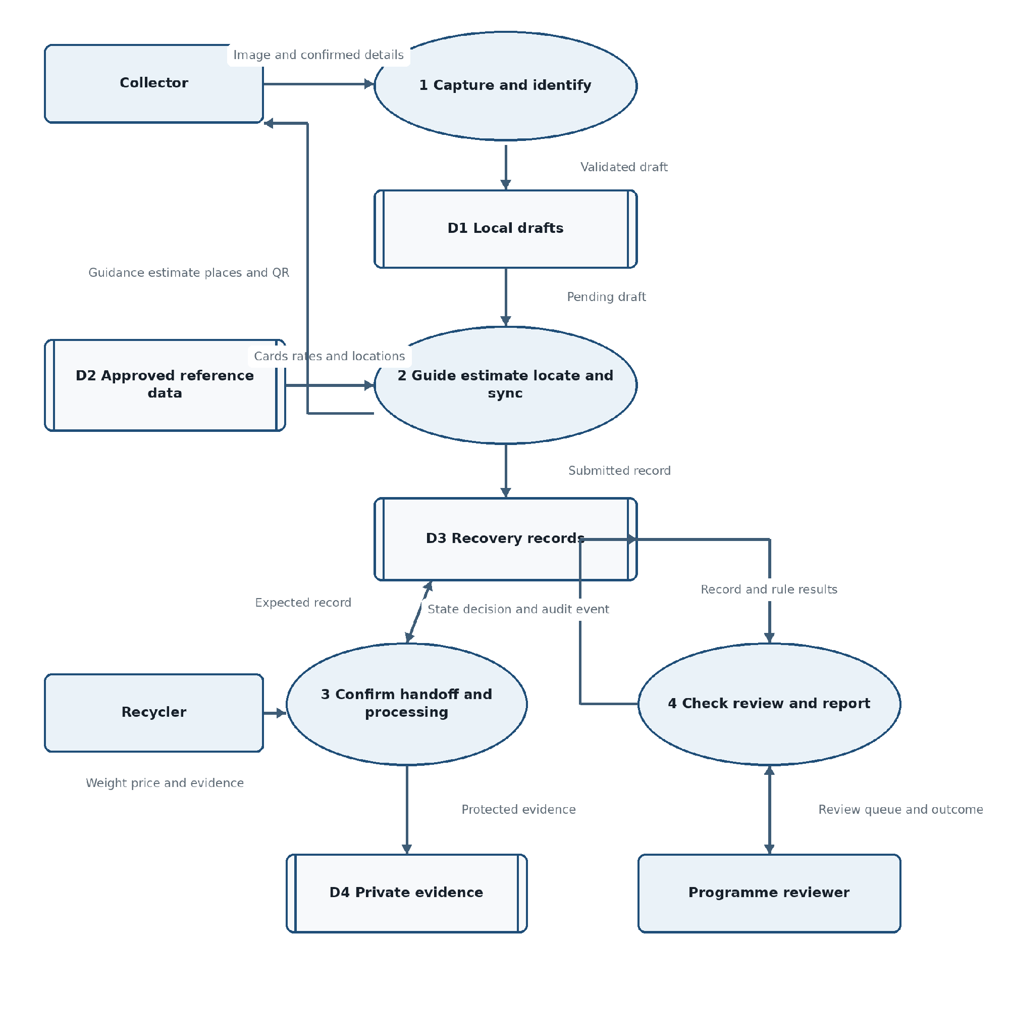
Figure 10. Level 1 data flow diagram

C.2 UML Use Case Diagram
The use case model defines the application capabilities available to the collector, recycler and programme reviewer. Association lines show participation; they do not imply that one actor may use another actor's permissions.
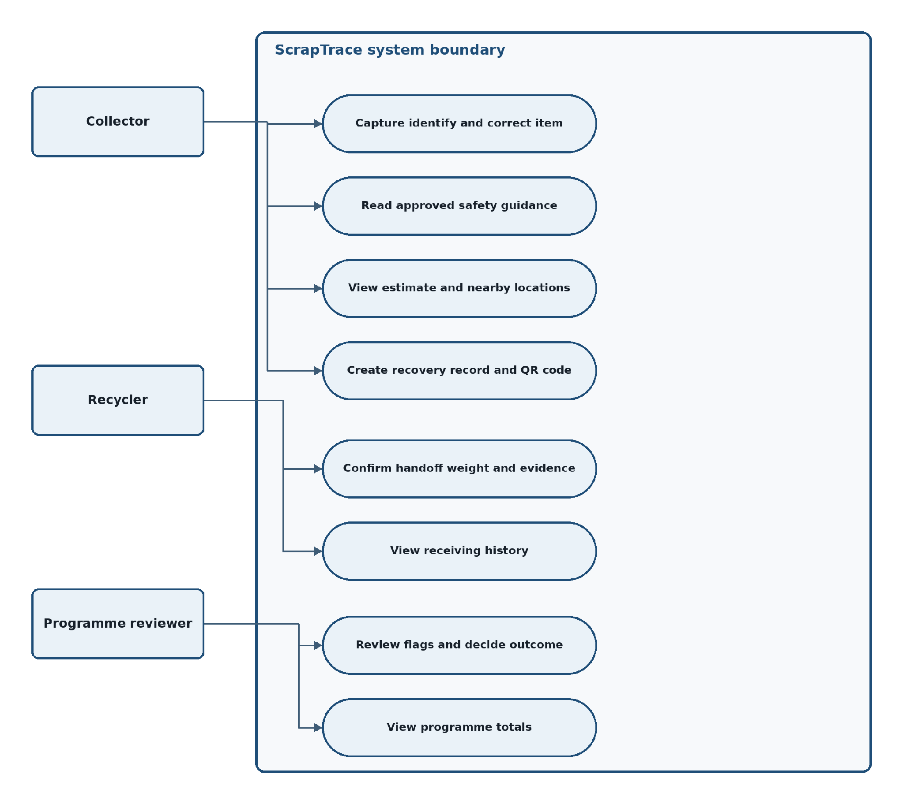
Figure 11. UML use case model

C.3 UML Class Diagram
The class model is a logical software design view. Composition indicates objects whose lifecycle belongs to the recovery record or handoff. Aggregation indicates related objects that may be absent while the record is still progressing.
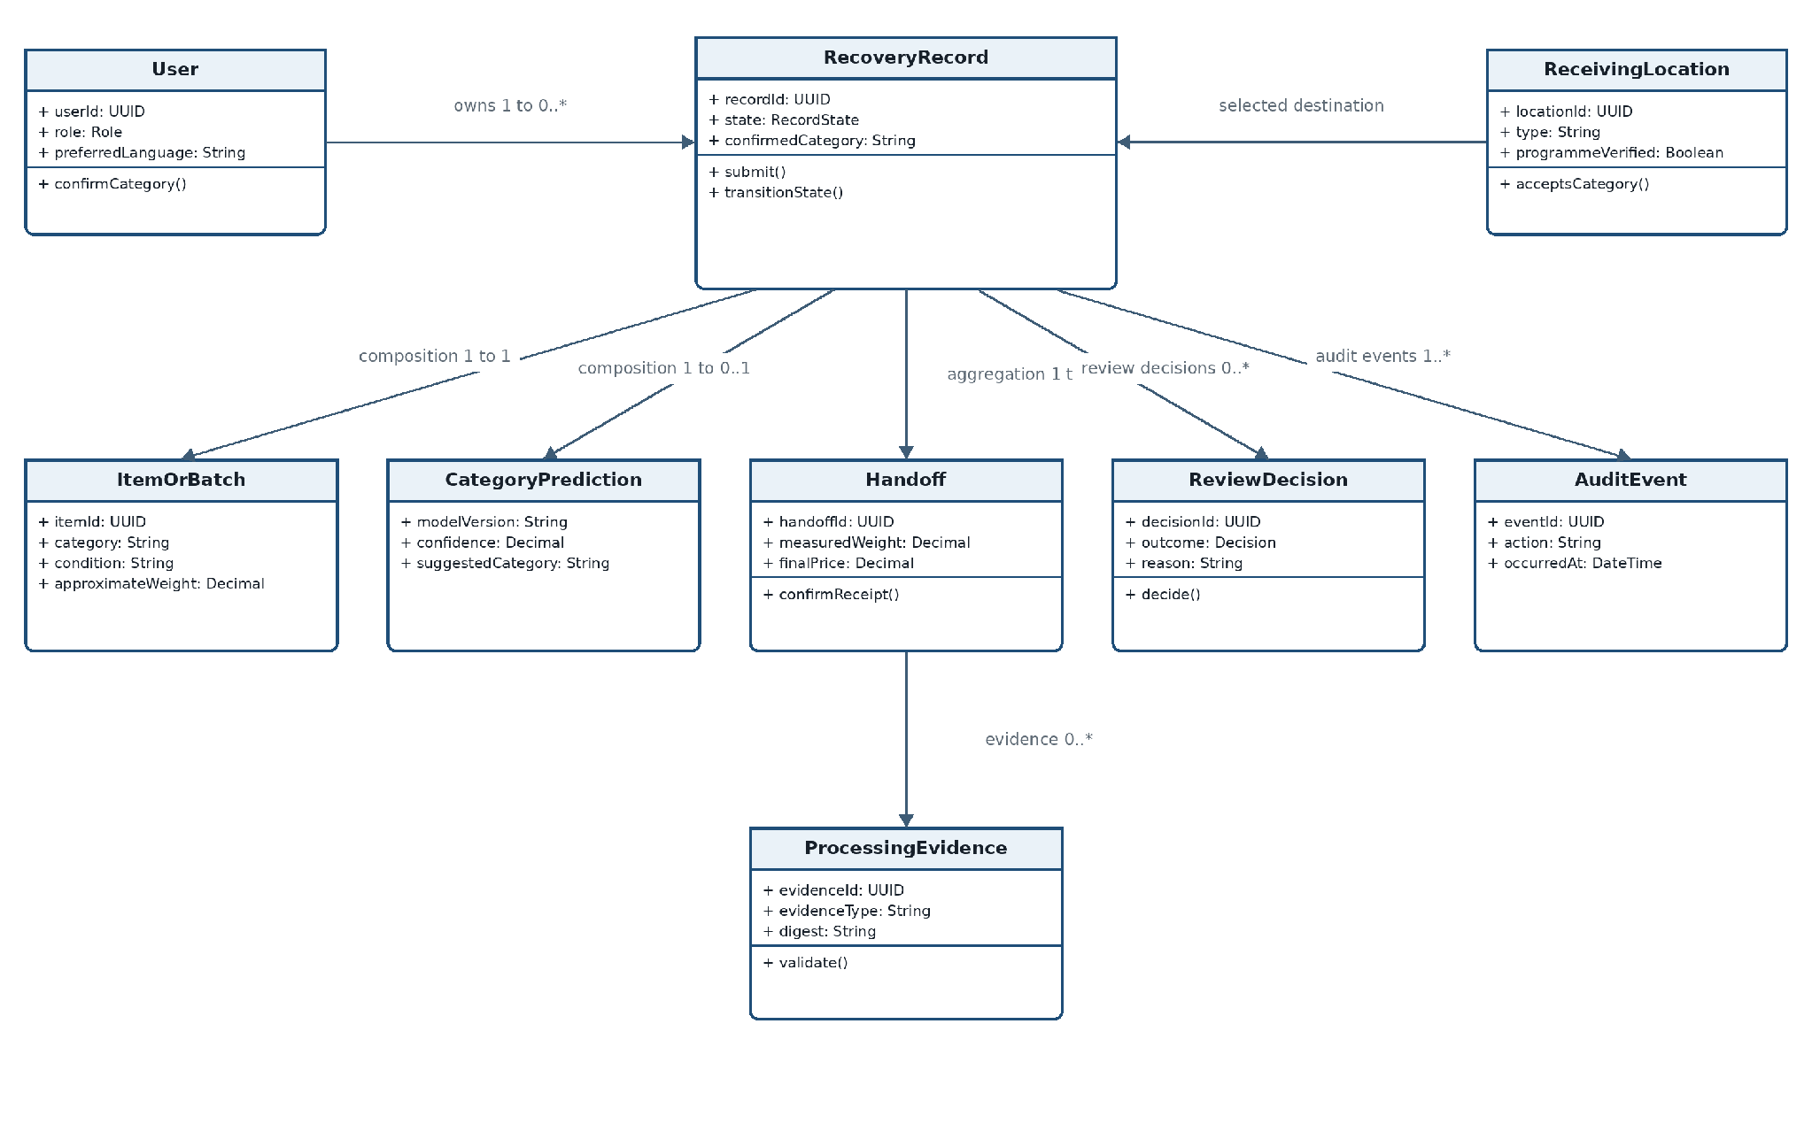
Figure 12. UML domain class model

C.4 State Transition Diagram
The state model is normative for recovery-record workflow. The application service shall reject any transition not shown here or not authorised for the acting role. A record that enters review remains excluded from approved totals until a reviewer records an outcome.
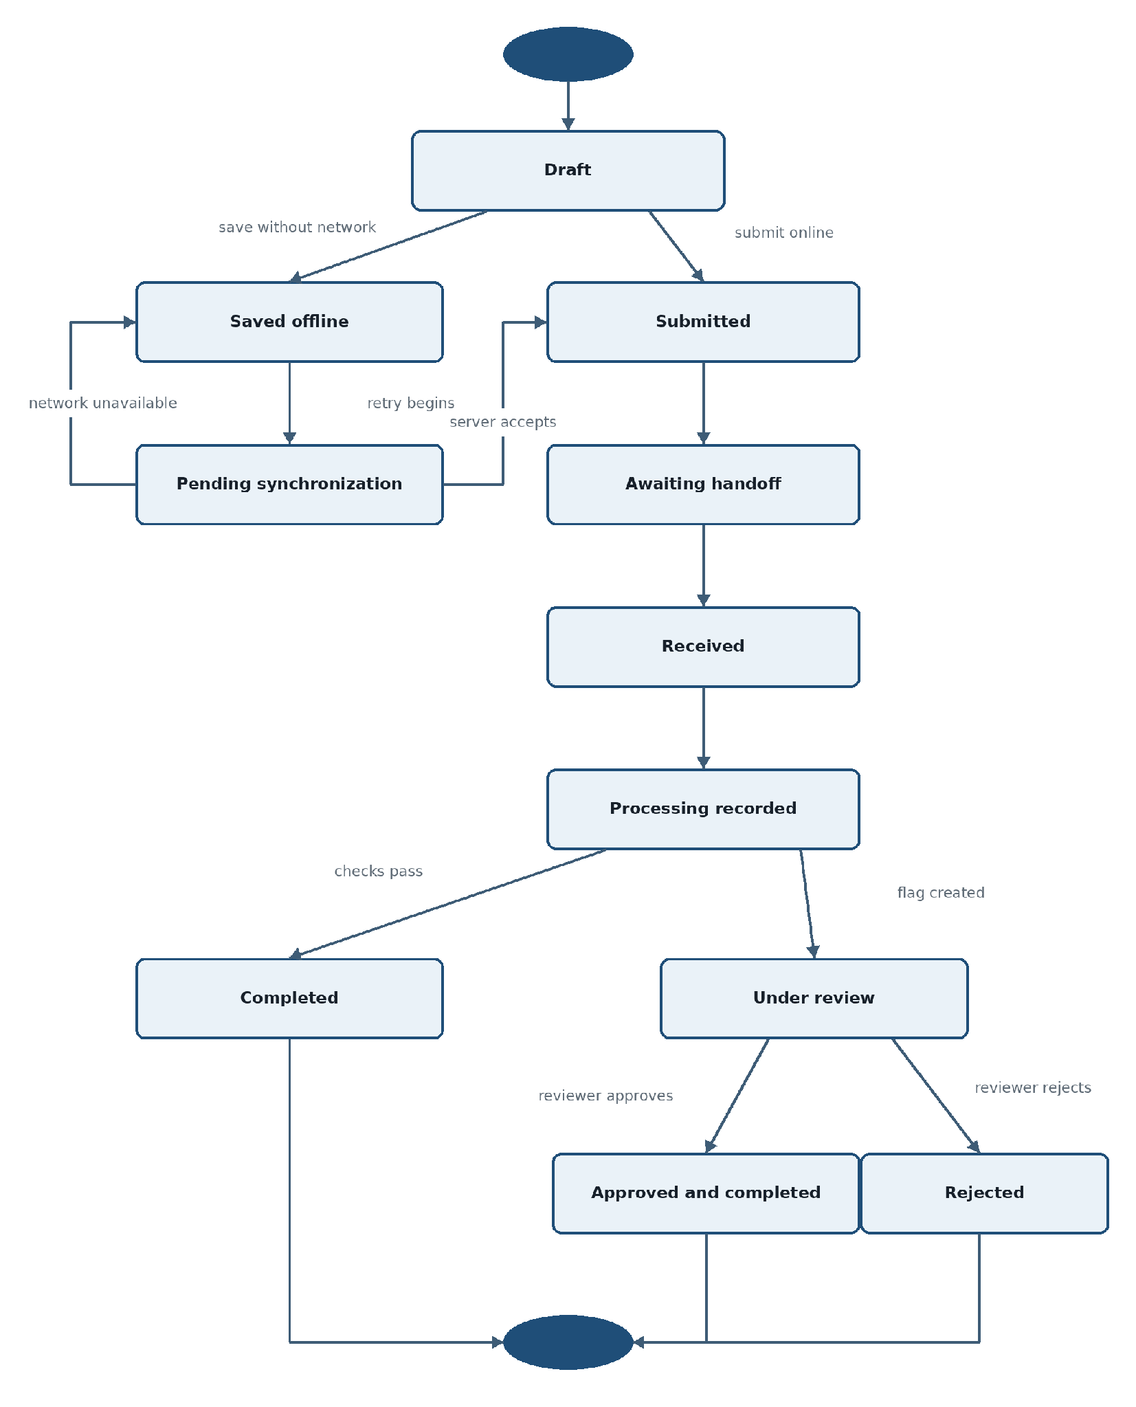
Figure 13. Recovery-record state-transition model

C.5 Entity Relationship Diagram
The ERD is the logical persistence model for the core traceability path. It shows primary keys, foreign keys and cardinalities. Supporting reference tables for safety cards, price rates and language bundles remain governed by the data dictionary in Section 4.1 and may be normalized further during physical database design.
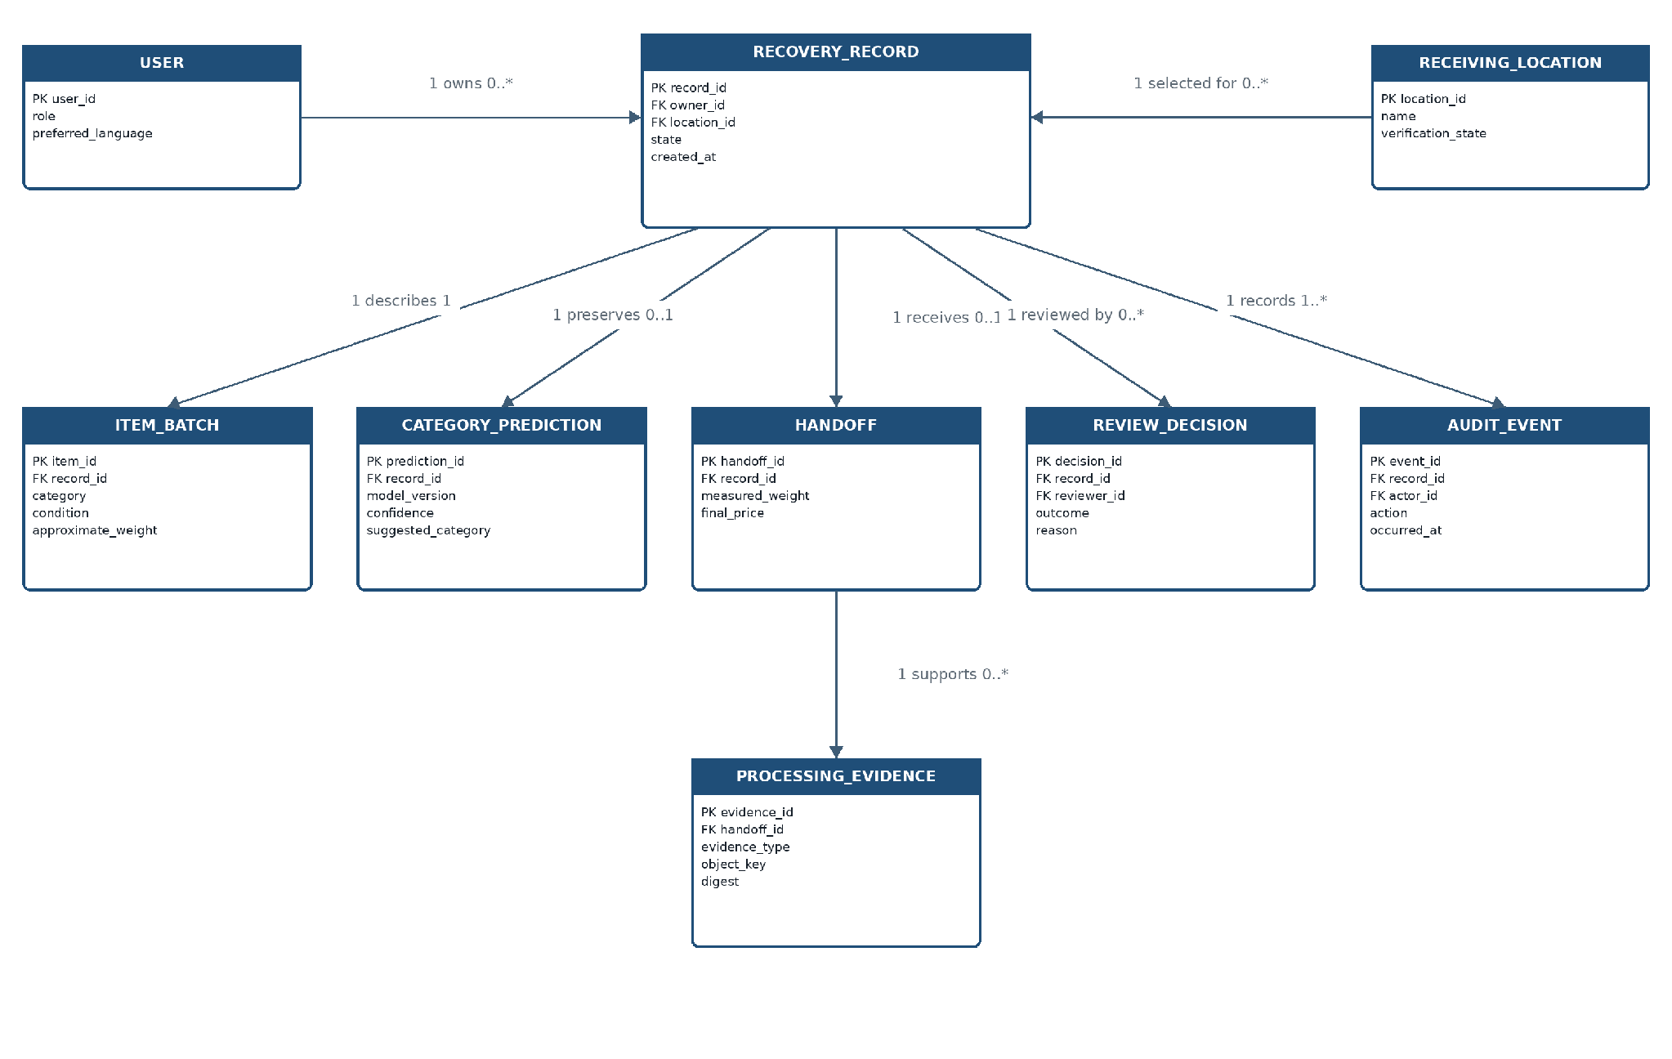
Figure 14. Core traceability entity-relationship model

Appendix D: Prioritization Rationale
Priority | Interpretation | Included examples | Deferral rule
Must | Required to prove a safe, useful end-to-end application. | Capture, confirmation, approved guidance, offline save, location, QR, handoff, evidence, review, journey. | Cannot be deferred if it breaks the acceptance scenario or a safety/privacy control.
Should | Strongly improves usefulness or learning but is not essential to the minimum safe journey. | Correction-review queue, anonymous network-gap report, information-request loop, simulated bonus. | May be deferred with product/engineering approval and documented limitation.
Could | Useful enhancement after Must/Should quality gates. | Text-to-speech and approved CSV export. | Implement only after core quality, accessibility and security gates pass.
Future / excluded | Requires authority, integration or operating scale beyond a hackathon application. | Live mobile money, official EPR credits, statutory certificates, automatic model deployment, national rollout. | Requires a new approved SRS, legal/operational agreements and field validation.

